Homework 19th February
*Please bring your reading book and spelling words in your homework folder everyday as we will be using them in class.*
Literacy | Phonics This week, we are starting work on our first joint phoneme – ‘sh’. 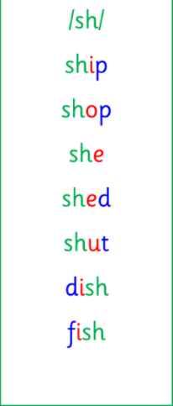 Common words and tricky words: - she - her - said 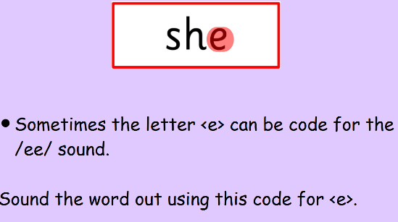 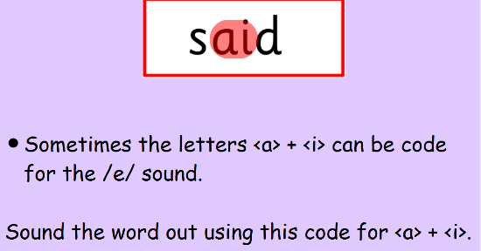 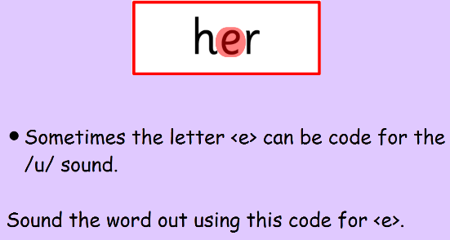 Use any of the activities to develop your phonics skills. Can you check that you – - can hear the phoneme in your words - see the phoneme in your words - say the phoneme in your words - sound out the words - write the words from your phoneme strips and any common words. Encourage learners to follow the five step rule: Say it, Break it, Make it, Blend it and Read it, then Write it. https://ictgames.com/mobilePage/writingRepeater/index.html  Reading Read your book to your adult. Remember to tell them what your book is called. There are some words that we cannot sound out in our books yet as we have not learnt all of our spelling rules. Our adults at home can help with this. With all CVC words, however, we want to be using the letter sounds and blending those words to read. We are also focusing on the importance of using your finger to follow the words as you read.  Writing Draw a picture of your favourite hobby (for example, football or dancing). Write a sentence independently detailing why it is your favourite hobby. https://www.autodraw.com/
Numeracy | In class, we have started learning about money. This week, we are working on recognising the different types of coin.  Play “The Coins Game” on Topmarks and practise sorting one coin into the money box. https://www.topmarks.co.uk/money/coins-game
Other | Practise some mindfulness at home. Mindfulness helps us feel happy and calm. There are lots of different mindfulness videos, but here are some of our class favourites –  Belly Breathing - https://www.youtube.com/watch?v=RiMb2Bw4Ae8  Rainbow Relaxation - https://www.youtube.com/watch?v=IIbBI-BT9c4  Bubble Bounce - https://www.youtube.com/watch?v=UEuFi9PxKuo
Contact details | If you have any issues about homework please contact:  Miss Ronald eaaimee.ronald@glow.sch.uk  Miss Barrett at eajaye.barrett@glow.sch.uk

