Homework 29th January
*Please bring your reading book and spelling words in your homework folder everyday as we will be using them in class.*
Literacy | Phonics  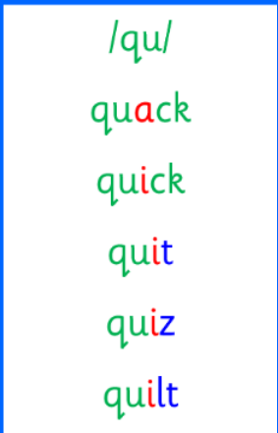 Common words  Tricky Words 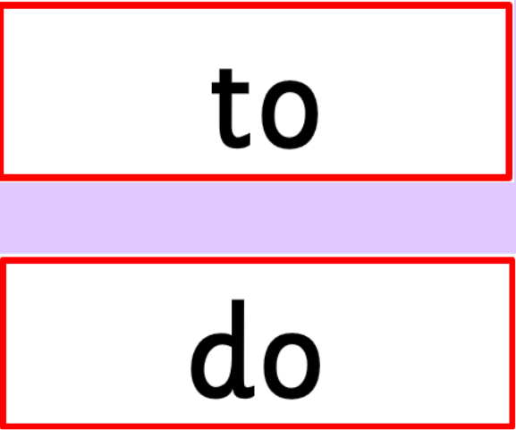 Sometimes the letter <o> can be code for the /oo/ sound. Sound the word out using this code for <o>. Use any of the activities to develop your phonics skills. Can you check that you – - can hear these sounds in words - see these letters in words - say these sounds in words - sound out the words write the words from your phoneme strips and common words. Practise sounding out your cvc and spelling words. Listen to your cvc and spelling words. Can you break them and then write them. https://ictgames.com/mobilePage/writingRepeater/index.html  Reading There are some words that we cannot sound out in our books yet as we havent learned all of our spelling rules, so our adults at home can help with this. With all CVC words, however, we want to be using the letter sounds and blending those words to read. Read your book to your adult. Remember to tell them what your book is called. You could also describe the characters in your story to an adult. We are focusing in class the importance of using your finger to follow the words as you read.  Writing but up went had us him for on get let and did Writing with our common words Choose three common words to practice and write three sentences. Draw a picture to match. Tell your adult what it is. Try and write your sentence yourself. Say your words nice and clearly then break them to help you spell. Remember finger spaces, full stops. https://www.autodraw.com/
Numeracy | In class, we have been learning about weight.  Go on a measurement scavenger hunt around your house.  Can you find heavy and light objects?
Other | On Thursday, we wrote instructions for “how to make a jeely piece”. Thinking about these steps, make a jeely piece with an adult at home. Remember to wash your hands before and after!
Contact details | If you have any issues about homework please contact:  Miss Barrett at eajaye.barrett@glow.sch.uk  Miss Ronald eaaimee.ronald@glow.sch.uk

