Homework Monday ^{7th} October
*Please bring your reading book in your homework folder everyday as we will be using them in class.*
All Primary 1 children have Outdoor Learning on a Tuesday. Please bring or wear appropriate footwear and jackets.
Literacy | Phonics 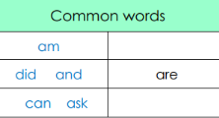 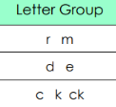 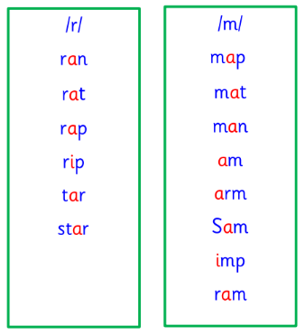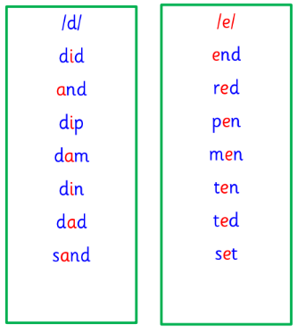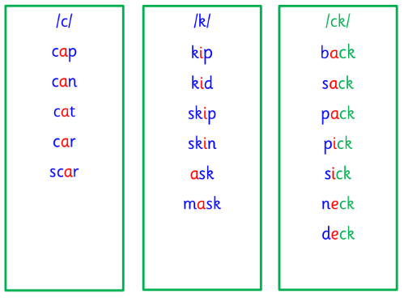 This week is a consolidation week, where learning from the past few sessions is recapped before moving on to new learning. Use any of the activities to develop your phonics skills Remember to check- - can hear these sounds in words - see these letters in words - say these sounds in words - and write the words from your phoneme strips and common words  Reading Retell the story in your book using the picture clues to help you. Here is a text that someone from your family could read to you. Listen carefully and then use what you have heard to answer the questions. 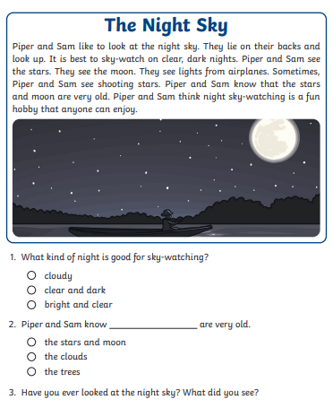  Writing 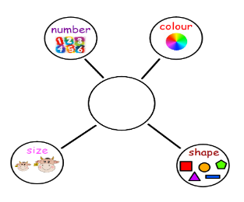 Here is the description bubble that we use in class to come up with ideas for writing. Can you use it to verbally give a description of a character of your choosing?
Numeracy | Can you use your knowledge of 2D shapes to compare or sort these shapes?  https://www.topmarks.co.uk/carroll-diagrams/2d-shapes  Can you match these 3D shapes to their names?  https://www.abcya.com/games/shape_match
Other | Try and go for Autumn walk with your family. Think about your senses (sight, hearing, smell and touch). What can your senses pick up on during your walk? Think about the changes from Summer to Autumn. Which changes do you like and why? Discuss with your family and compare the similarities and differences in your opinions.
If you have any issues about homework please contact Miss Whiteford on eavictoria.whiteford@glow.sch.uk
and Miss Barrett at
eajaye.barrett@glow.sch.uk

