Homework Tuesday ^{16th} September
*Please bring your reading book and spelling words in your homework folder everyday as we will be using them in class.*
All Primary 1 children have Outdoor Learning on a Tuesday. Please bring or wear appropriate footwear and jackets.
Literacy | Phonics Use any of the activities to develop your phonics skills Remember to check- - can hear these sounds in words - see these letters in words - say these sounds in words - and write the words from your phoneme strips and common words  Reading Read a story with your family. Before turning each page can you predict (guess) what might happen?  Writing Can you write the capital and lower case letters for the sounds we have learned so far? Aa Tt Ss Ii Pp Nn
Numeracy | Use the QR code or link to develop your numbers to 20 skills. You can play find the missing number or find the number 1 less/1 more.  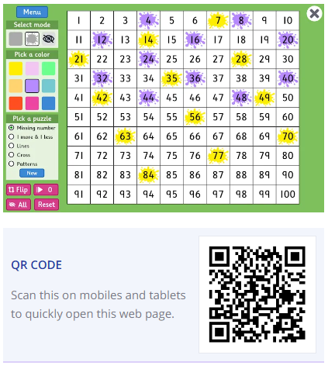  https://www.topmarks.co.uk/learning-to-count/paint-the-squares
Other | Can you give yourself a compliment? It could be about trying hard with something you find tricky, doing a task well or for being a good friend.
If you have any issues about homework please contact Miss Whiteford on eavictoria.whiteford@glow.sch.uk
and Miss Barrett at
eajaye.barrett@glow.sch.uk

