Homework Monday ^{9th} September
*Please bring your reading book in your homework folder everyday as we will be using them in class.*
All Primary 1 children have Outdoor Learning on a Tuesday. Please bring or wear appropriate footwear and jackets.
Literacy | Phonics This week is a consolidation week. We recap what we have learned before moving on to new learning. Can you check that you - can hear these sounds in words - see these letters in words - say these sounds in words - and write the words from your phoneme strips and common words  Reading Retell the story in your book using the picture clues to help you. Remember to include who, what, where and when.  Writing Can you write your name independently? Can you write your first and second name?
Numeracy | 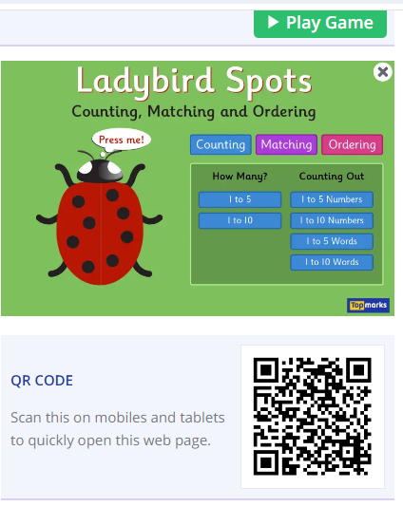  Scan this QR code or use this link to count, match and order numbers to 10.  https://www.topmarks.co.uk/learning-to-count/ladybird-spots
Other | Can you bring a small toy from home to talk to the class about on Friday?
If you have any issues about homework please contact Miss Whiteford on eavictoria.whiteford@glow.sch.uk
and Miss Barrett at
eajaye.barrett@glow.sch.uk

