Homework 22nd September
All Primary 1 children have Outdoor Learning on a Thursday.
Literacy
  Phonics  Tricky words learned so far  the  I  is  Common words learned so far  a  at  it  in  an  As we now know 6 letter sounds we are beginning encourage and develop blending (using the letter sounds) to allow children to sound out the word.  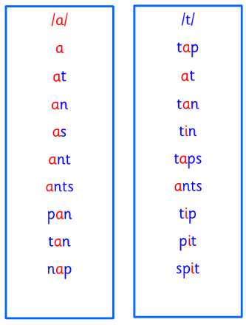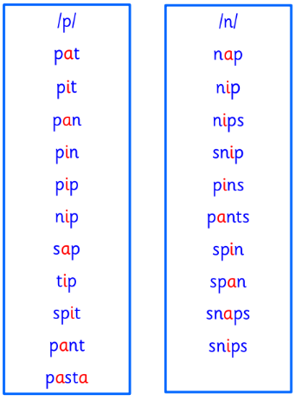 | Ask your children  Can they say the sound the letters make  Can they hear the sounds in words e.g. apple, cat  Can they tell you where they hear the sound, is it at the start/middle/end?  When written down can they find the letters in words  Can they write the letters using the correct letter formation  As we now know 6 letter sounds, we are beginning encourage and develop blending (using the letter sounds) to allow children to sound out the word.
Numeracy | Activity: work on your number skills to 20.  Using the Splat Grid, you could:  Play find the missing number  Play find the number 1 less/1 more.  Use the grid to count forwards and backwards.  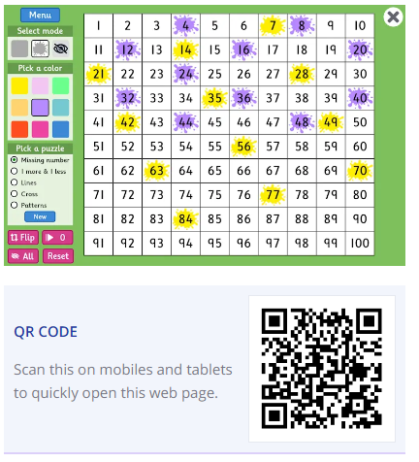  https://www.topmarks.co.uk/learning-to-count/paint-the-squares
If you have any issues about homework, please contact:
Miss Barrett at eajaye.barrett@glow.sch.uk
Ms Sharif at eazara.sharif@glow.sch.uk

