Homework WB 1st June 2026

Literacy
  Phonics  This week, we are consolidating our recently taught joined phonemes:    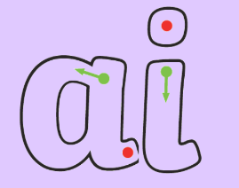  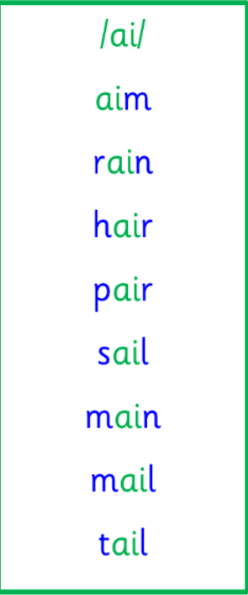  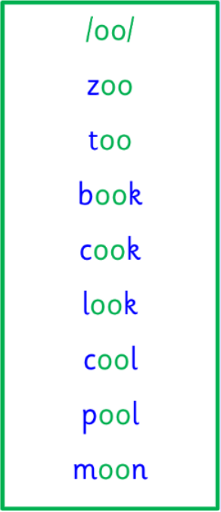  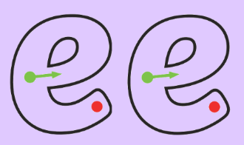  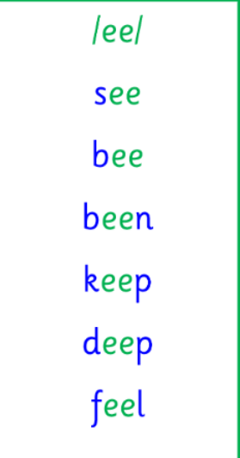  Common words and tricky words  We are also focusing on consolidation of our common words and tricky words, with particular focus on our tricky words (red words). Can you practice using these words in a sentence?  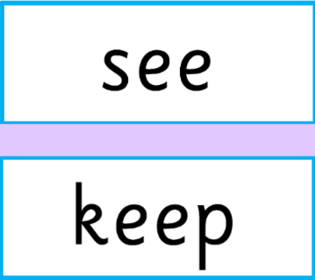  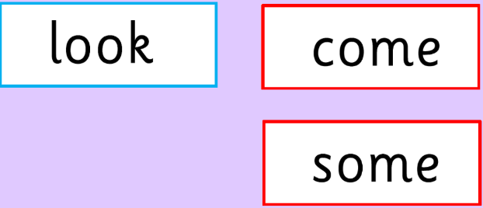  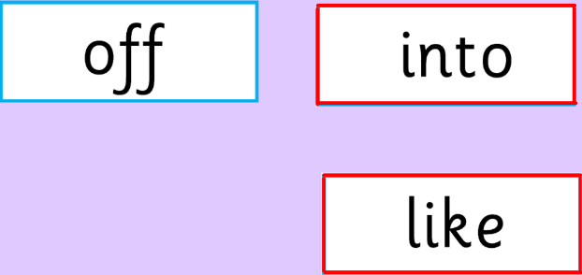 | Use any of the activities to develop your phonics skills. Can you check that you –  - can hear the phoneme in your words  - see the phoneme in your words  - say the phoneme in your words  - sound out the words  - write the words from your phoneme strips and any common words.  Encourage learners to follow the five step rule:  Say it, Break it, Make it, Blend it and Read it, then Write it.  https://ictgames.com/mobilePage/writingRepeater/index.html  Try learning your phoneme and words, through some active spelling strategies too. You could use pasta, shaving foam, porridge oats, sand to practice making your sounds and words. Can you draw a picture of something that has your sound in it? Use the word list this week to help you!  Please continue to practice all initial sounds at home:  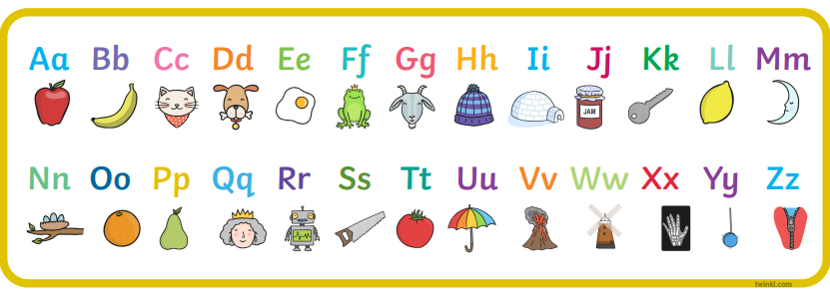  https://www.youtube.com/watch?v=wg-bW_TNmuA
  Reading  Physical reading books have been sent home in folders today. Please make sure that learners bring these every day for reading in class. New books will be given on a Monday. Please make sure learners bring their old books on a Monday, in order to get their new ones handed out. | Read through your book with an adult. Practice blending all your words.  Can you answer the comprehension questions at the back?  Challenge yourself:  Can you make up some questions of your own and ask a family member?  Think about what, when, why, where and this might help you create some questions.
  Writing  Activity 1: Talk to an adult about when you should use lowercase letters and when you should use uppercase letters.  Activity 2: Practice forming your letters – lowercase and uppercase. Make sure that all letters are the right way round! | 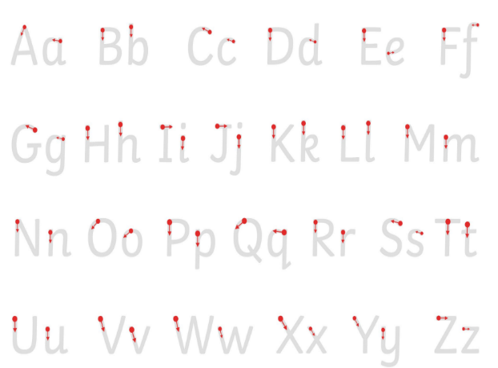
Numeracy | Odd and Even Numbers  In P1 this week, we are revising our odd and even numbers to 20.  Activity 1: Take a new page in your jotter and spilt it in half. On one half, write all your odd numbers to 20 and on the other half write all the even numbers to 20. The number line below can you help you if you are stuck. Odd numbers are in black and even numbers are green.  Challenge: can you make up a song or rhyme to help you remember your odd and even numbers to 20?  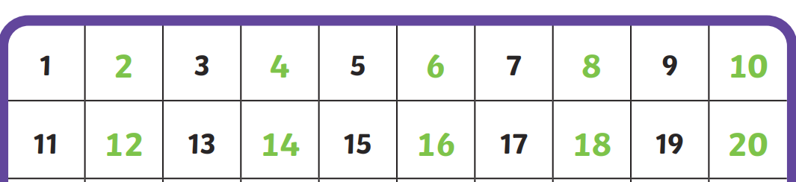
Other | Relax at home and take care of your body.  Choose something that you find relaxing, for example: reading a story, colouring, playing outside, or enjoy a Cosmic Yoga:  https://www.youtube.com/watch?v=xhWDiQRrC1Y  Reminder: remember to bring a doll or teddy for our ‘looking after a baby session’ on Tuesday
Contact details | If you have any issues about homework, please contact:  Miss Ronald at eaaimee.ronald@glow.sch.uk  Miss Whiteford at eavictoria.whiteford@glow.sch.uk  Miss Barrett at eajaye.barrett@glow.sch.uk

