Homework WB 11th May 2026

Literacy
  Phonics  This week, we are working on a new sound:  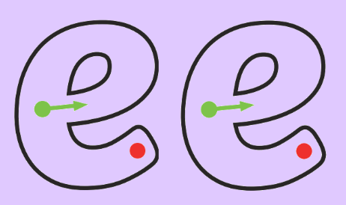  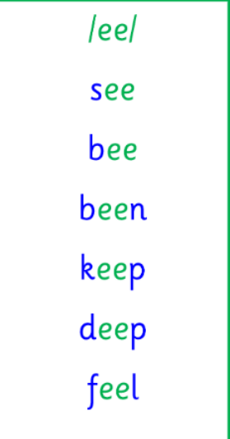  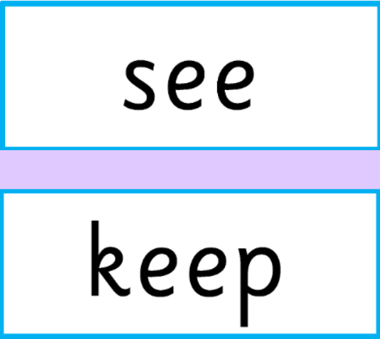 | Use any of the activities to develop your phonics skills. Can you check that you –  - can hear the phoneme in your words  - see the phoneme in your words  - say the phoneme in your words  - sound out the words  - write the words from your phoneme strips and any common words.  Encourage learners to follow the five step rule:  Say it, Break it, Make it, Blend it and Read it, then Write it.  https://ictgames.com/mobilePage/writingRepeater/index.html  Try learning your phoneme and words, through some active spelling strategies too. You could use pasta, shaving foam, porridge oats, sand to practice making your sounds and words. Can you draw a picture of something that has your sound in it? Use the word list this week to help you!  Please continue to practice all initial sounds at home:  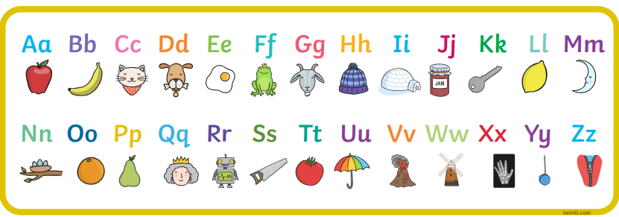  https://www.youtube.com/watch?v=wg-bW_TNmuA
  Reading  Physical reading books have been sent home in folders today. Please make sure that learners bring these every day for reading in class. New books will be given on a Monday. Please make sure learners bring their old books on a Monday, in order to get their new ones handed out. | Read through your book with an adult. Practice blending all your words.  Can you answer the comprehension questions at the back?  Challenge yourself:  Discuss the following points:  Where the book is set?  Who is in the book?  What is happening?  How did you feel about the story? Did you like it, not like it?
  Writing  Write a few descriptive sentences about one of the monsters in the picture.  For example, “The monster is red and small. He has one eye and jaggy teeth.” | 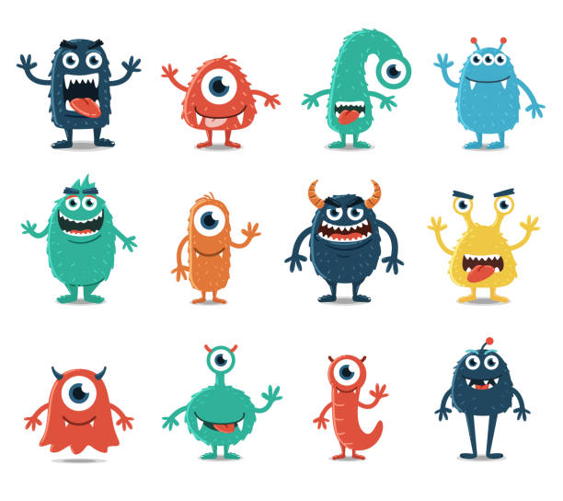
Numeracy | Data Handling  This week, we are introducing Carroll Diagrams. Play the TopMarks to explore more:  https://www.topmarks.co.uk/carroll-diagrams/2d-shapes  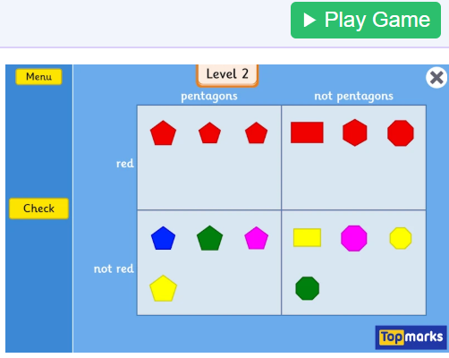
Other | With an adult or family member, discuss your school values.  What are you doing well to follow the school values? What, if anything, could you do better? Set yourself some goals for the final term.  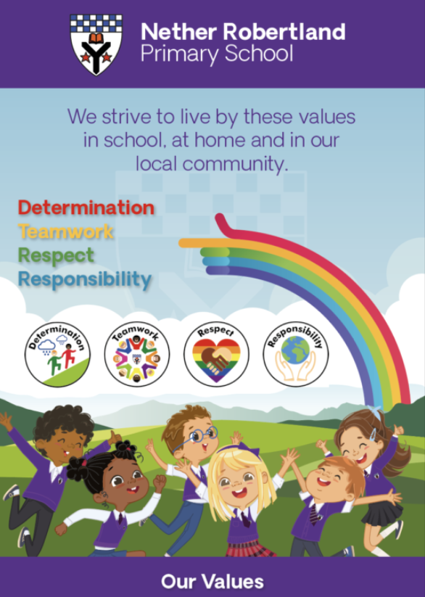  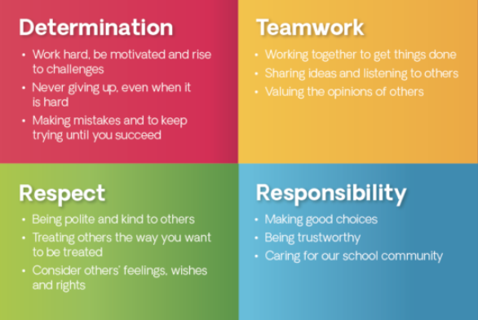
Contact details | If you have any issues about homework, please contact:  Miss Ronald at eaaimee.ronald@glow.sch.uk  Miss Whiteford at eavictoria.whiteford@glow.sch.uk  Miss Barrett at eajaye.barrett@glow.sch.uk

