Homework WB 16th March 2026

Literacy
  Phonics  This week, we are working on:  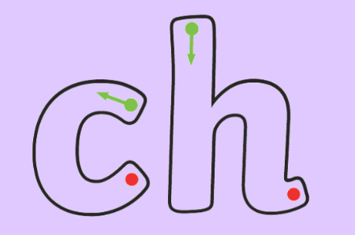  https://www.youtube.com/watch?v=xuld36YrFYs  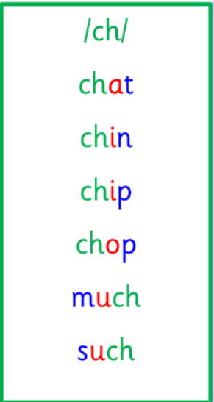  Common words and tricky words  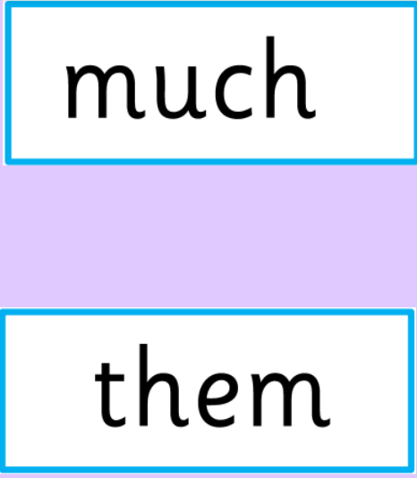 | Use any of the activities to develop your phonics skills. Can you check that you –  - can hear the phoneme in your words  - see the phoneme in your words  - say the phoneme in your words  - sound out the words  - write the words from your phoneme strips and any common words.  Encourage learners to follow the five step rule:  Say it, Break it, Make it, Blend it and Read it, then Write it.  https://ictgames.com/mobilePage/writingRepeater/index.html  Try learning your phoneme and words, through some active spelling strategies too. You could use pasta, shaving foam, porridge oats, sand to practice making your sounds and words. Can you draw a picture of something that has your sound in it? Use the word list this week to help you!  Please continue to practice all initial sounds at home:  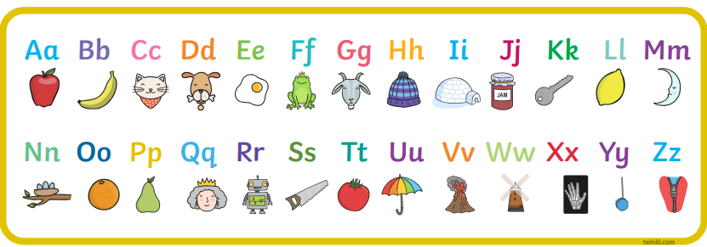  https://www.youtube.com/watch?v=wg-bW_TNmuA
  Reading  Physical reading books have been sent home in folders today. Please make sure that learners bring these every day for reading in class. New books will be given on a Monday. Please make sure learners bring their old books on a Monday, in order to get their new ones handed out. | Read through your book with an adult. Practice blending all your words. Can you answer the comprehension questions at the back?
  Writing  Recount writing  Write a sentence and draw a picture about your weekend.  For example,  “At the weekend, I went to the park.” | 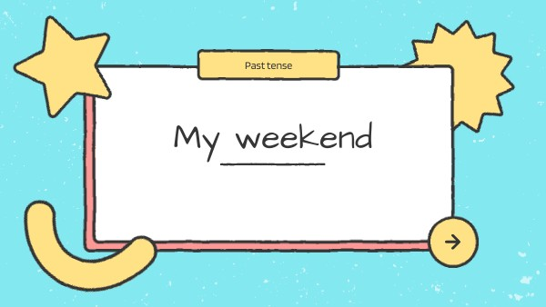
Numeracy | Numbers  This week, we are consolidating our learning on money. Practice recognising all your coins to £2 and adding to 10p, using our familiar songs and games to help you.  https://www.youtube.com/watch?v=dFzAU3u06Ps  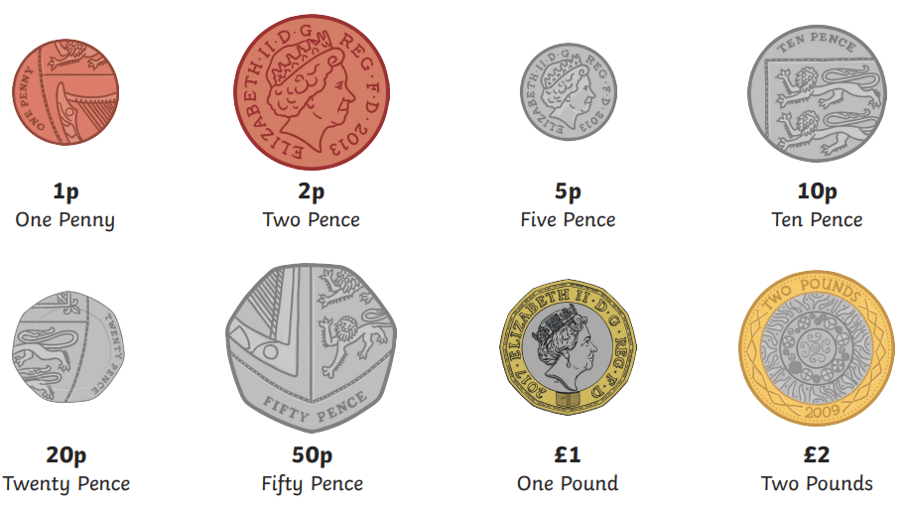  TopMarks Money games - https://www.topmarks.co.uk/Search.aspx?q=money (see below)  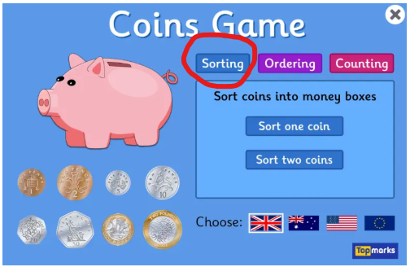  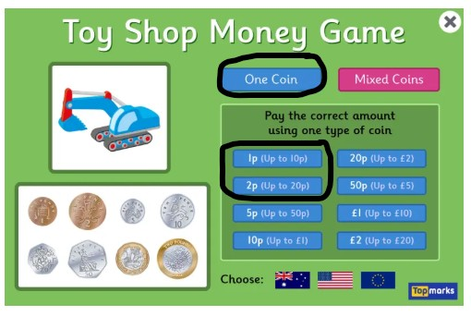
Other | Talk to an adult about your trip to Dean Park.  What did you learn? What was your favourite part?  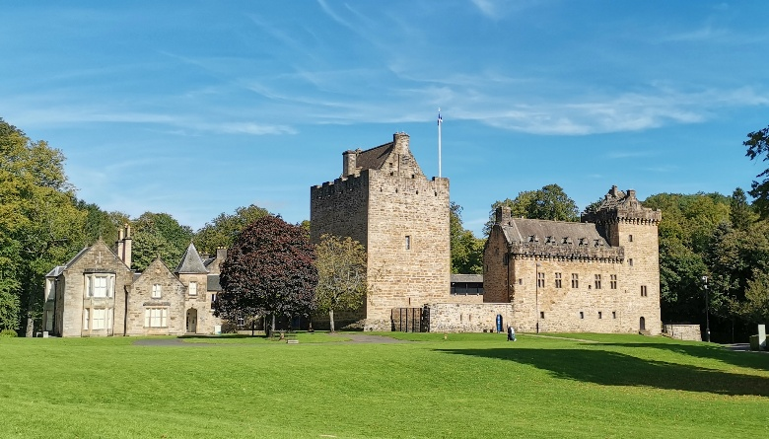
Contact details | If you have any issues about homework, please contact:  Miss Ronald at eaaimee.ronald@glow.sch.uk  Miss Whiteford at eavictoria.whiteford@glow.sch.uk  Miss Barrett at eajaye.barrett@glow.sch.uk

