Homework WB 16th February 2026

Literacy
  Phonics  This week, we are consolidating our common words and tricky words:  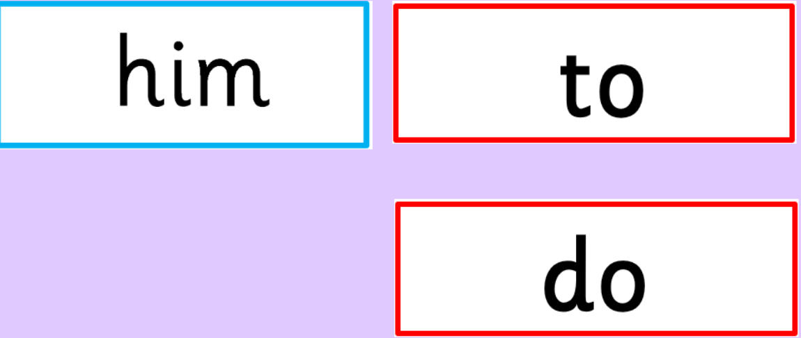  We are also looking at three new tricky words:  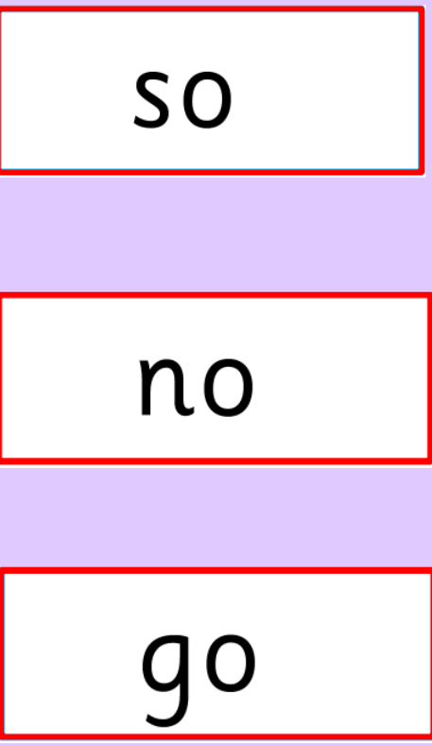  Sounds  We have now learnt all our initial sounds. Continue to practice all sounds at home:  Jolly Phonics a to z song: https://www.youtube.com/watch?v=wg-bW_TNmuA  This song does not include qu or x, see links below:  https://www.youtube.com/watch?v=zsvzy6DoO54  https://www.youtube.com/watch?v=aurzlkmeuPc&list=RDaurzlkmeuPc&start_radio=1  https://www.youtube.com/watch?v=fHlUS4NRc9I&list=RDfHlUS4NRc9I&start_radio=1 | Work with an adult to check that:  - you can hear your sounds in words  - you can see your sounds in words  - you can say your words of the week  - you can write your sounds and your words of the week  - recognise any rules in your tricky words  Encourage learners to follow the five step rule: Say it, Break it, Make it, Blend it and Read it, then Write it.  https://ictgames.com/mobilePage/writingRepeater/index.html  Try learning your sounds and words, through some active spelling strategies too. You could use pasta, shaving foam, porridge oats, sand to practice making your sounds and words.  Can you draw a picture of something that has your sound in it? Use the word list this week to help you!
  Reading  Physical reading books have been sent home in plastic folders today. Please make sure that learners bring these every day for reading in class. New books will be given on a Monday. Please make sure learners bring their old books on a Monday, in order to get their new ones handed out. | Read through your book with an adult. Practice blending all your words. Can you answer the comprehension questions at the back?
  Writing  Think back to your senses walk with your adult last week. If you did not manage to go on a senses walk or exploration last week, then try to go on one with your family this week. Think about our senses work in class and chat with your family about what you see, hear, smell, touch and taste. | Activity:  Draw a picture to show your senses walk experience. Then, write a sentence to describe it.  Remember we made a word mat first to help us with our sense writing piece. Maybe you could do the same at home to help you!
Numeracy | Numbers  This week, learners are working on missing number problems.  Activity 1: Write out a number line from 0-20. Use the one below to help.  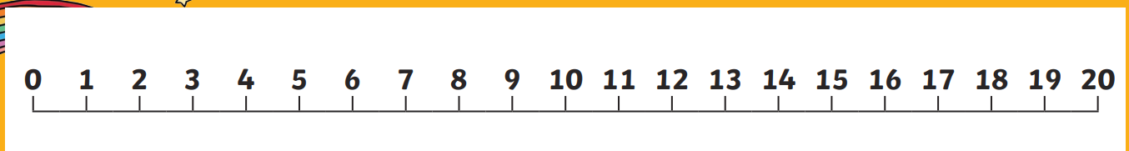  Activity 2: Fill in the missing numbers on the number line. You can use your own number line, from activity 1, to help if you are stuck.  Missing number problems  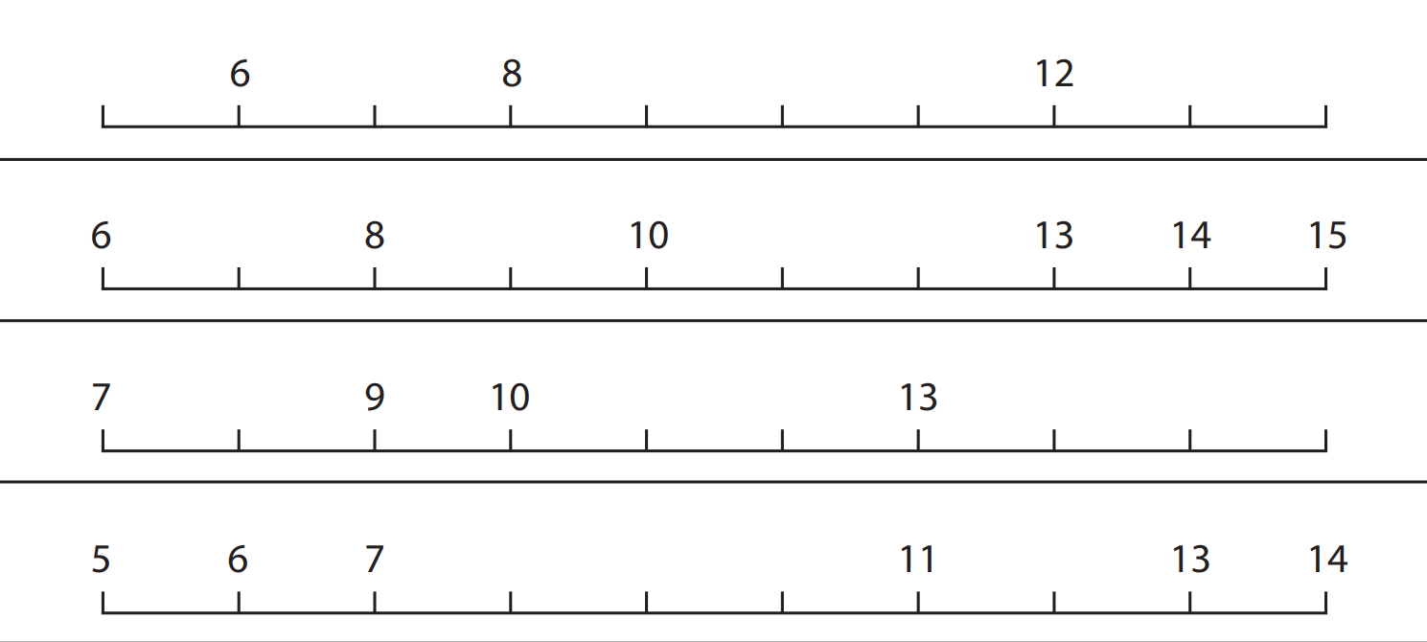
Other | In topic, we have been learning about Scottish Inventions. Talk to an adult about your learning. If you could invent anything in the world, what would it be and why?
Contact details | If you have any issues about homework, please contact:  Miss Ronald at eaaimee.ronald@glow.sch.uk  Miss Whiteford at eavictoria.whiteford@glow.sch.uk  Miss Barrett at eajaye.barrett@glow.sch.uk

