Homework WB 2nd February 2026

Literacy
  Phonics  This week, we are working on two new sounds:  Jolly Phonics song ‘qu’ –  https://www.youtube.com/watch?v=zsvzy6DoO54  https://www.youtube.com/watch?v=aurzlkmeuPc&list=RDaurzlkmeuPc&start_radio=1  Jolly Phonics song ‘x’ - https://www.youtube.com/watch?v=fHlUS4NRc9I&list=RDfHlUS4NRc9I&start_radio=1  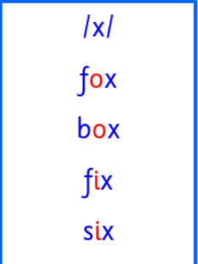  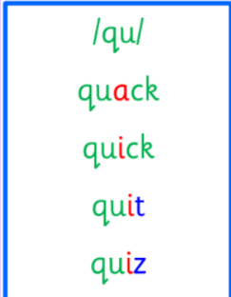  Common and tricky words  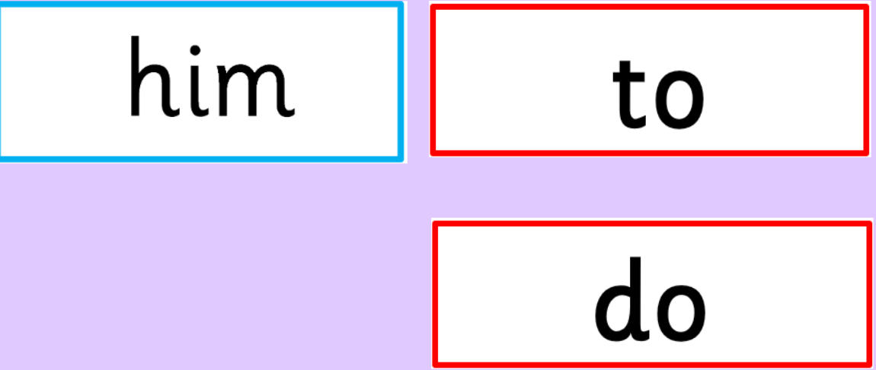 | Work with an adult to check that:  - you can hear your sounds in words  - you can see your sounds in words  - you can say your words of the week  - you can write your sounds and your words of the week  - recognise any rules in your tricky words  Encourage learners to follow the five step rule: Say it, Break it, Make it, Blend it and Read it, then Write it.  https://ictgames.com/mobilePage/writingRepeater/index.html  Try learning your sounds and words, through some active spelling strategies too. You could use pasta, shaving foam, porridge oats, sand to practice making your sounds and words.  Can you draw a picture of something that has your sound in it? Use the word list this week to help you!
    q(u)
    x
  Reading  Physical reading books have been sent home in plastic folders today. Please make sure that learners bring these every day for reading in class. New books will be given on a Monday. Please make sure learners bring their old books on a Monday, in order to get their new ones handed out. | Read through your book with an adult. Practice blending all your words. Can you answer the comprehension questions at the back?
  Writing  Write a sentence about this cat.  Learners should work on making and breaking their words as independently as possible.  Remember full stops, capital letters and finger spaces in your writing. | 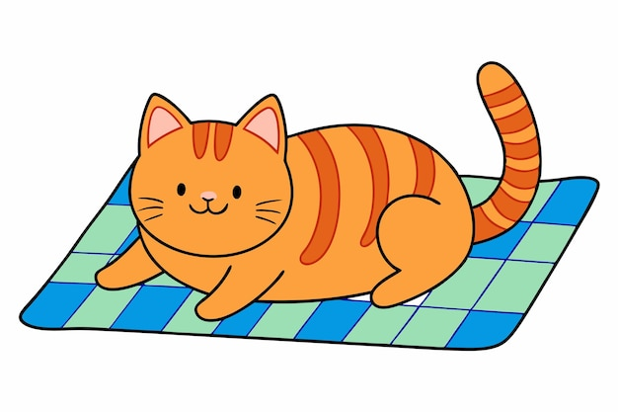
Numeracy | Number work  Learners are beginning to work on their addition skills.  Play the TopMarks game to practice addition to 10:  https://www.topmarks.co.uk/addition/addition-to-10
Other | We have been learning about the importance of looking after our bodies. Relaxing our mind and body is very important.  Practice some Cosmic Yoga:  https://youtu.be/xhWDiQRrC1Y?feature=shared  Think about how you feel before the yoga? And, then how do you feel after? Do you feel different?
Contact details | If you have any issues about homework, please contact:  Miss Ronald at eaaimee.ronald@glow.sch.uk  Miss Whiteford at eavictoria.whiteford@glow.sch.uk  Miss Barrett at eajaye.barrett@glow.sch.uk

