Homework WB 19th January 2026

Literacy
  Phonics  This week, we are working on two new sounds:  Jolly Phonics song ‘y’ - https://www.youtube.com/watch?v=9bMHn0-fYw8  Jolly Phonics song ‘z’ - https://www.youtube.com/watch?v=Q3P5JM3BAPU  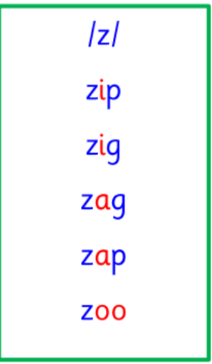  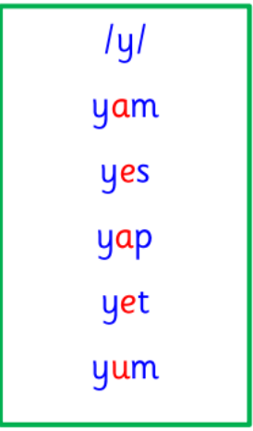  Common and tricky words  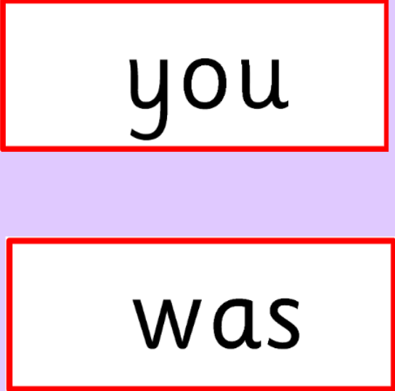 | Work with an adult to check that:  - you can hear your sounds in words  - you can see your sounds in words  - you can say your words of the week  - you can write your sounds and your words of the week  - recognise any rules in your tricky words  Encourage learners to follow the five step rule: Say it, Break it, Make it, Blend it and Read it, then Write it.  https://ictgames.com/mobilePage/writingRepeater/index.html  Try learning your sounds and words, through some active spelling strategies too. You could use pasta, shaving foam, porridge oats, sand to practice making your sounds and words.  Can you draw a picture of something that has your sound in it? Use the word list this week to help you!
    y
    z
  Reading  Physical reading books have been sent home in plastic folders today. Please make sure that learners bring these every day for reading in class. New books will be given on a Monday. Please make sure learners bring their old books on a Monday, in order to get their new ones handed out. | Read through your book with an adult. Practice blending all your words. Can you answer the comprehension questions at the back?
  Writing  This week, P1 are being visited by a Mystery Reader. Once your visitor has been, draw a picture to show what happened. With an adult, write a sentence to describe the visit. | 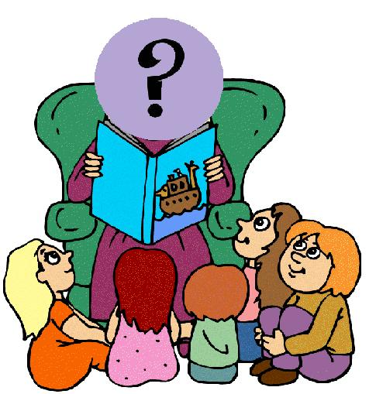
Numeracy | Measurement  This week, we have started work on measurement, beginning with length and height.  Discuss with an adult what the terms: tall, small, long and short mean. Can you give some examples for each?  Then go on a length hunt around your house. Draw two pictures of each:  tall, small, long and short.
Other | This Tuesday 20th January, three learners from each P1 will be chosen to represent their class and perform at the school’s Scottish assembly.  P1’s chosen poem is “The Wee Rid Motor”.  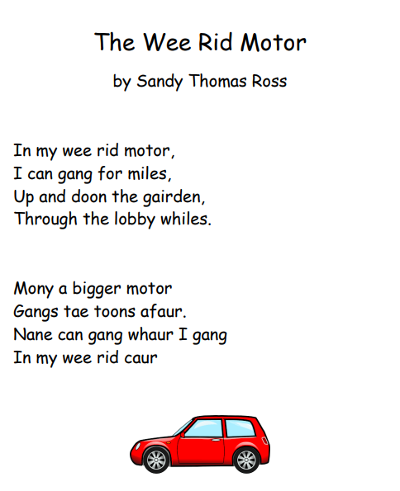  https://www.youtube.com/watch?v=fgVCPTxnQI8
Contact details | If you have any issues about homework, please contact:  Miss Ronald at eaaimee.ronald@glow.sch.uk  Miss Barrett at eajaye.barrett@glow.sch.uk

