Homework WB 1st December 2025

Literacy
  Phonics  This week, we are consolidating the following sounds:  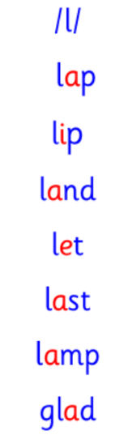  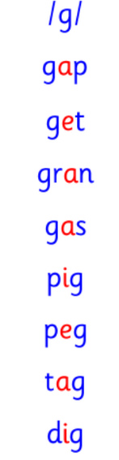  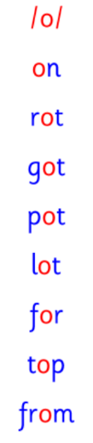  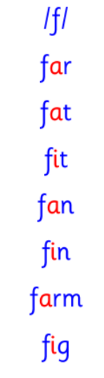  Common and tricky words  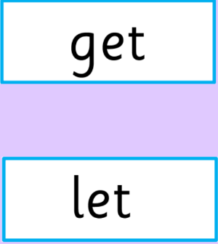  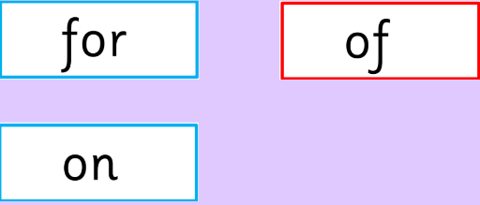 | This week is a consolidation week. We are recapping what we have learnt so far. Check that:  - you can hear your sounds in words  - you can see your sounds in words  - you can say your words of the week  - you can write your sounds and your words of the week  - recognise any rules in your tricky words  Encourage learners to follow the five step rule: Say it, Break it, Make it, Blend it and Read it, then Write it. https://ictgames.com/mobilePage/writingRepeater/index.html  Try learning your sounds and words, through some active spelling strategies too. You could use pasta, shaving foam, porridge oats, sand to practice making your sounds and words.  Challenge: can you write a sentence with one or more of your words?
    g | f
    l | o
  Reading
  Every week, our learners will be assigned a book. Learners should access this online and read their book with an adult. There are also questions and a quiz for each book, to aid learners’ comprehension.
  Please log-in and access your Rockets Phonics account, using the information provided to you at parents’ night. If you have problems, please see Miss Ronald at the class door.
  Writing  Draw a picture and write a sentence about our trip to the panto on Wednesday. | 
Numeracy | Fractions  In class, we have started work on fractions. In P1, we are learning about halves.  Talk to an adult about your learning so far.  Activity: draw four shapes in your jotter. Can you show an adult how you would half this shape?  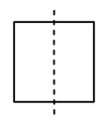  For example:
Other | Practice your parts for The Nativity.
Contact details | If you have any issues about homework, please contact:  Miss Ronald at eaaimee.ronald@glow.sch.uk  Miss Barrett at eajaye.barrett@glow.sch.uk

