Homework WB 10th November 2025

Literacy
  Phonics  This week, we are consolidating the following sounds:  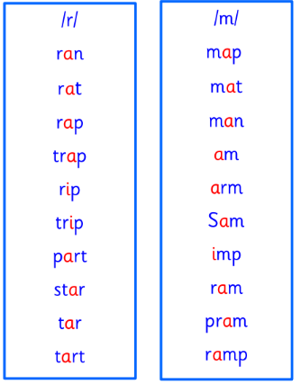  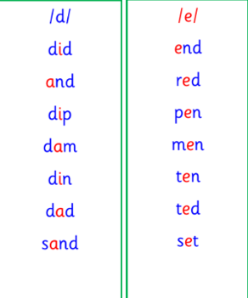  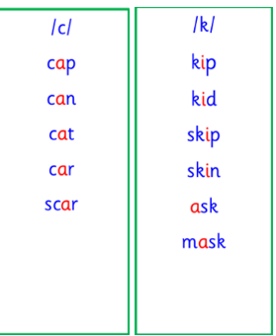  This week, we will also be consolidating our knowledge of common words and tricky words.  Practise the words below with an adult. | This week is a consolidation week. We are recapping what we have learnt so far. Check that:  - you can hear your sounds in words  - you can see your sounds in words  - you can say your words of the week  - you can write your sounds and your words of the week  - recognise any rules in your tricky words  Encourage learners to follow the five step rule: Say it, Break it, Make it, Blend it and Read it, then Write it. https://ictgames.com/mobilePage/writingRepeater/index.html  Try learning your sounds and words, through some active spelling strategies too. You could use pasta, shaving foam, porridge oats, sand to practice making your sounds and words.
    r | d | c | k
    m | e | ck
    am | did | and
    can | ask | are
  Reading
  This week, we are starting online reading books through Rocket Phonics.
  Every week, our learners will be assigned a book. Learners should access this online and read their book with an adult. There are also questions and a quiz for each book, to aid learners’ comprehension.
  Please log-in and access your Rockets Phonics account, using the information provided to you at parents’ night. If you are unsure of your learners’ log-in or have any issues logging in, then please see Miss Ronald at the class door.
  Writing | Practice writing your first name. Make sure you are using a capital letter for the start of your name, and then using lowercase letters for the rest of your name.  Challenge: practice writing your surname.
Numeracy | Time  We have been learning about the different hands on an analogue clock.  We have been learning to read o’clock on an analogue clock.  Using the interactive clock, discuss the different hands with an adult and what they mean. Then, see if you can make the following times on your clock:  1 o’clock  4 o’clock  7 o’clock  9 o’clock  11 o’clock  https://www.topmarks.co.uk/time/teaching-clock
Other | In P.E., we have been doing gymnastics.  Can you practice some balances and jumps at home?
Contact details | If you have any issues about homework, please contact:  Miss Ronald at eaaimee.ronald@glow.sch.uk  Miss Barrett at eajaye.barrett@glow.sch.uk

