Homework WB 6th October 2025

Literacy
  Phonics  In phonics, we have been learning our initial sounds.  This week, we are working on:  Examples of words are:  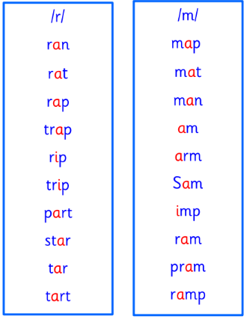  Our words of the week are: | Can you think of words that have your sounds of the week in them? What words start with ‘r? What words start with ‘m’? Can you think of any words that have both these sounds in them? Work with an adult to check that:  - you can hear your sounds in words  - you can see your sounds in words  - you can say your words of the week  - you can write your sounds and your words of the week  - recognise any rules in your tricky words  Encourage learners to follow the five step rule: Say it, Break it, Make it, Blend it and Read it, then Write it.  https://ictgames.com/mobilePage/writingRepeater/index.html  Try learning your sounds and words, through some active spelling strategies too. You could use pasta, shaving foam, porridge oats, sand to practice making your sounds and words.
    r
    m
    am
  Reading | Personal Reading  Choose a story to read with your family. Talk about your favourite part. Challenge yourself: can you find this week’s sounds in your story? r m
  Writing | Number formation  Can you practice writing your numbers from 0-20?  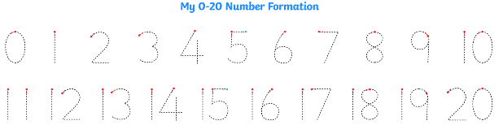
Numeracy | Patterns and Shape  In school, we have been learning about patterns. Play the TopMarks game to practise completing and copying patterns: https://www.topmarks.co.uk/ordering-and-sequencing/shape-patterns  
Other | With Mrs Singleton, P1 have been learning French numbers to 10.  Have a listen to the song and practise your numbers to 10 with an adult: https://www.youtube.com/watch?v=WNOZLPK7-g8
Contact details | If you have any issues about homework, please contact:  Miss Ronald at eaaimee.ronald@glow.sch.uk  Miss Barrett at eajaye.barrett@glow.sch.uk

