Homework WB 22nd September
Literacy | Phonics In phonics, we have been learning our initial sounds. This week, we are working on: p n Examples of words are: Our words of the week are: is an Can you think of words that have your sounds of the week in them? What words start with ‘s’? What words start with ‘i’? Can you think of any words that have both these sounds in them? Work with an adult to check that: - you can hear your sounds in words - you can see your sounds in words - you can say your words of the week - you can write your sounds and your words of the week - recognise any rules in your tricky words Encourage learners to follow the five step rule: Say it, Break it, Make it, Blend it and Read it, then Write it. https://ictgames.com/mobilePage/writingRepeater/index.html Try learning your sounds and words, through some active spelling strategies too. You could use pasta, shaving foam, porridge oats, sand to practice making your sounds and words.  Reading  Activity: In class, we have been working on story predictions. At home, read a story with your family. Before turning each page can you predict (guess) what might happen?  Learners are now working on Lilac First Steps books. These books are for whole-class learning only and will not be assigned for homework. After we have learnt our first set of initial sounds in class, learners will then be assigned Pink A books on Rocket Phonics. Log-ins for this are in the front page of homework jotters and instructions for accessing are on the class blog.  Writing  In your homework jotter, can you write the capital and lower case letters for the sounds we have learned so far?  Aa Tt Ss Ii Pp Nn  *Challenge: can you write:  ant tin sat pan
Numeracy | Activity: work on your number skills to 20.  Using the Splat Grid, you could:  - Play find the missing number  - Play find the number 1 less/1 more.  - Use the grid to count forwards and backwards.  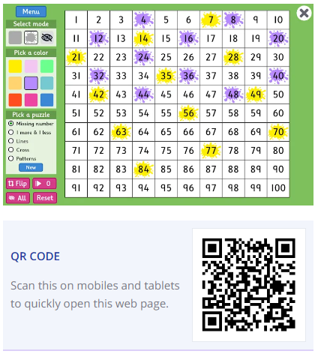  https://www.topmarks.co.uk/learning-to-count/paint-the-squares
Other | Can you give yourself a compliment? It could be about trying hard with something you find tricky, doing a task well or for being a good friend.
Contact details | If you have any issues about homework, please contact:  Miss Ronald at eaaimee.ronald@glow.sch.uk  Miss Barrett at eajaye.barrett@glow.sch.uk

