Homework 24th March
Literacy
  Phonics  This week, we are working on a new joined phoneme – ‘ng’.  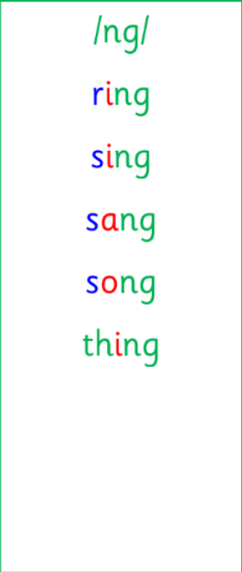 | Use any of the activities to develop your phonics skills. Can you check that you –  - can hear the phoneme in your words  - see the phoneme in your words  - say the phoneme in your words  - sound out the words  - write the words from your phoneme strips and any common words.  Encourage learners to follow the five step rule:  Say it, Break it, Make it, Blend it and Read it, then Write it.  https://ictgames.com/mobilePage/writingRepeater/index.html
    Common words | Tricky words
     | 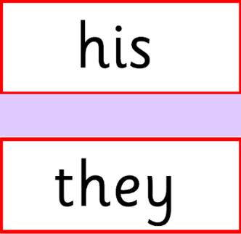
  Reading  New reading books, for this week, have been assigned on Rockets Phonics. Learners should access this online and read their book with an adult.  Please let me know of any issues as soon as possible. | Read your book to your adult.  Remember to tell them what your book is called. Use your phonics knowledge to sound out and blend your words. Then, answer the questions at the end of your story.
  Writing  Recount writing | Draw a detailed picture and write an independent sentence about Red Nose Day in school last Friday. What was your favourite part? What activities did you do in the afternoon?  https://www.autodraw.com/
Numeracy | As a whole class, we have been working on addition to 10.  Explore these TopMarks games to help you learn more:  https://www.topmarks.co.uk/addition/robot-addition  https://www.topmarks.co.uk/addition/addition-to-10
Other | In P.E., we have been practising our balances during gymnastics. Show an adult your one-point, two-point and three-point balances. Remember to be safe!
Contact details | If you have any issues about homework please contact:  Miss Ronald eaaimee.ronald@glow.sch.uk  Miss Barrett at eajaye.barrett@glow.sch.uk

