Homework 17th March
*Please bring your reading book and spelling words in your homework folder everyday as we will be using them in class.*
Literacy
  Phonics  This week, we are working on consolidation in class. Please revise all four joined phonemes that we have been working on, as well as common words and tricky words.  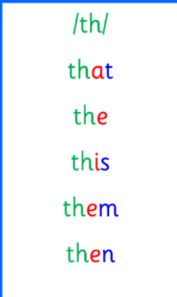  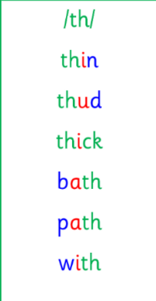  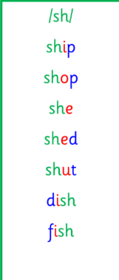  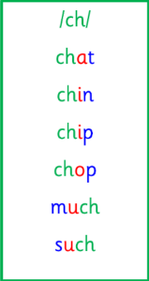 | Use any of the activities to develop your phonics skills. Can you check that you –  - can hear the phoneme in your words  - see the phoneme in your words  - say the phoneme in your words  - sound out the words  - write the words from your phoneme strips and any common words.  Encourage learners to follow the five step rule:  Say it, Break it, Make it, Blend it and Read it, then Write it.  https://ictgames.com/mobilePage/writingRepeater/index.html
    Common words | Tricky words
    her  with  this  that  then  much  them | she  said  my  by
  Reading  New reading books, for this week, have been assigned on Rockets Phonics. Learners should access this online and read their book with an adult.  Please let me know of any issues as soon as possible. | Read your book to your adult.  Remember to tell them what your book is called. Use your phonics knowledge to sound out and blend your words. Then, answer the questions at the end of your story.
  Writing  Imaginative Writing | In school, we have been taking part in lots of STEM activities, including the Leaders’ Award. The Leaders’ Award asks the question “If you were an engineer, what would you do?” Write a sentence to answer this question.  https://www.autodraw.com/
Numeracy | As a whole class, we are continuing to work on our recognition of coins to £2.  Discuss the different coins and their values.  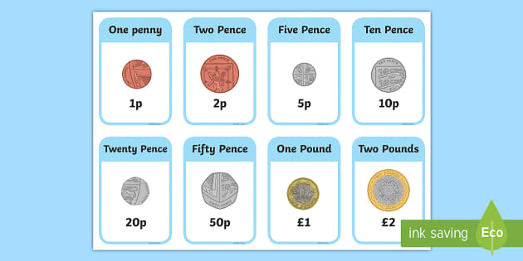  Learners have also been working on adding to 10p. Children can use the TopMarks game to challenge themselves - https://www.topmarks.co.uk/money/coins-game
Other | Red Nose Day is this Friday. Comic Relief has partnered with Bluey to give us lots of fun activities and learning resources. As part of this partnership, Bluey focuses on the importance of relationships and safety.  Draw a picture of all the people in your life who are important to you and the people who keep you safe.
Contact details | If you have any issues about homework please contact:  Miss Ronald eaaimee.ronald@glow.sch.uk  Miss Barrett at eajaye.barrett@glow.sch.uk

