Homework 10th March
*Please bring your reading book and spelling words in your homework folder everyday as we will be using them in class.*
Literacy
  Phonics  This week, we are working on our next joint phoneme – ‘ch’.  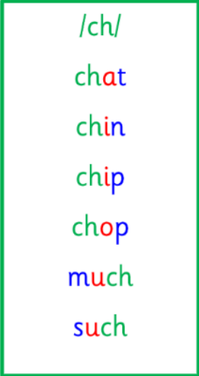  Common words:  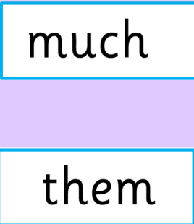 | Use any of the activities to develop your phonics skills. Can you check that you –  - can hear the phoneme in your words  - see the phoneme in your words  - say the phoneme in your words  - sound out the words  - write the words from your phoneme strips and any common words.  Encourage learners to follow the five step rule:  Say it, Break it, Make it, Blend it and Read it, then Write it.  https://ictgames.com/mobilePage/writingRepeater/index.html
  Reading  New reading books, for this week, have been assigned on Rockets Phonics. Learners should access this online and read their book with an adult.  Please let me know of any issues as soon as possible. | Read your book to your adult.  Remember to tell them what your book is called. Use your phonics knowledge to sound out and blend your words. Then, answer the questions at the end of your story.
  Writing  Imaginative Writing | Create your own story about a special trip to the beach or park. Using your imagination, think about: what might happen at the beach; and who are the characters in our story? Draw an imaginative picture and write a sentence to match.  https://www.autodraw.com/
Numeracy | Practice counting backwards from 0-20 - https://www.youtube.com/watch?v=ShqXL-zfLxY  Then, practice ordering your numbers from 0-20, on TopMarks.  - Caterpillar ordering - https://www.topmarks.co.uk/ordering-and-sequencing/caterpillar-ordering  - Chinese Dragon Game - https://www.topmarks.co.uk/ordering-and-sequencing/chinese-dragon-ordering  - Coconut Ordering - https://www.topmarks.co.uk/ordering-and-sequencing/coconut-ordering
Other | For the next two weeks, we are taking part in STEM/World of Work week.  Discuss with an adult all the different types of jobs you can do. What might you like to do when you are older?
Contact details | If you have any issues about homework please contact:  Miss Ronald eaaimee.ronald@glow.sch.uk  Miss Barrett at eajaye.barrett@glow.sch.uk

