Homework 25th February
*Please bring your reading book and spelling words in your homework folder everyday as we will be using them in class.*
Literacy
  Phonics  This week, we are starting work on our first joint phoneme – soft ‘th’.  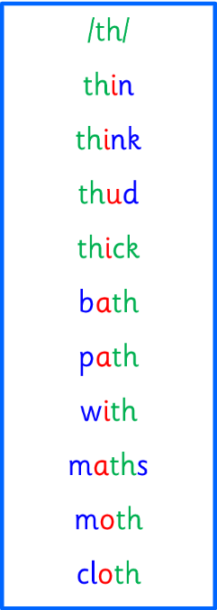  Common words and tricky words:  - with  - my  - by  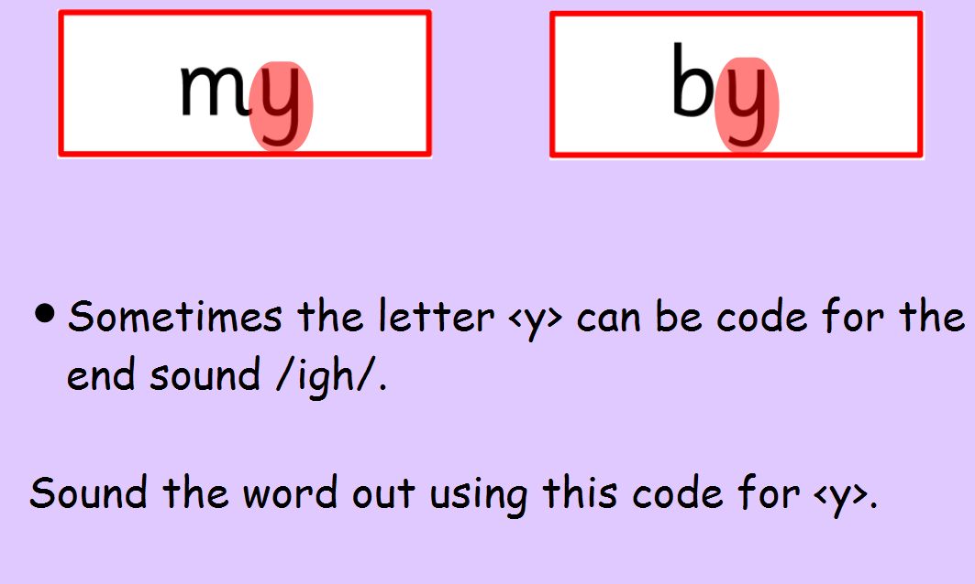 | Use any of the activities to develop your phonics skills. Can you check that you –  - can hear the phoneme in your words  - see the phoneme in your words  - say the phoneme in your words  - sound out the words  - write the words from your phoneme strips and any common words.  Encourage learners to follow the five step rule:  Say it, Break it, Make it, Blend it and Read it, then Write it.  https://ictgames.com/mobilePage/writingRepeater/index.html
  Reading  This week, for homework, we will be focusing on the book “Mr Men in Scotland”.  https://www.youtube.com/watch?v=-UnSKPDZqLw | Speak to an adult about the Scottish features that you see in “Mr Men in Scotland” – can you see castles, bridges, animals, foods?
  Writing | Draw a picture of a Scottish wild animal and write a sentence telling your family where it lives or what it eats.  Use your knowledge of sounds to break words and spell them.  https://www.autodraw.com/
Numeracy | In class, we are continuing to learn about money. This week, we are working on ordering the different types of coin. Play “The Coins Game” on Topmarks and practise ordering coins into the money box, in order from lowest amount to highest amount.  https://www.topmarks.co.uk/money/coins-game  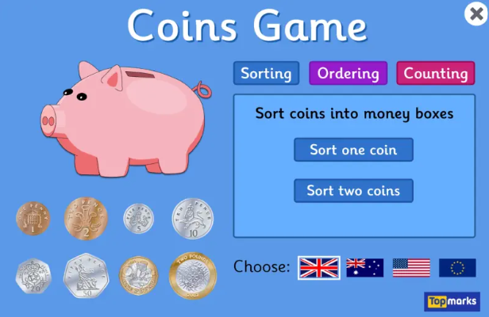
Other | This month’s article from the UNCRC is 16 The Right to Privacy.  Discuss with your adults what you think privacy means.  Think about a fairy tale such as Goldilocks and the Three Bears.  Did Goldilocks respect the privacy of the bears?  What happened because of this?
Contact details | If you have any issues about homework please contact:  Miss Ronald eaaimee.ronald@glow.sch.uk  Miss Barrett at eajaye.barrett@glow.sch.uk

