Homework 3rd February
*Please bring your reading book and spelling words in your homework folder everyday as we will be using them in class.*
Literacy
  Phonics  This week, we are working on consolidation and assessment.  Looking at the word list on page 2, learners should choose the common words and tricky words they wish to practice. We have been working on these words in class. Learners should continue to focus on sounding out their common words and reading their tricky words. As a whole class, we are also continuing to focus on ‘q(u)’ and ‘x’.  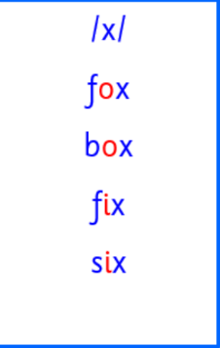  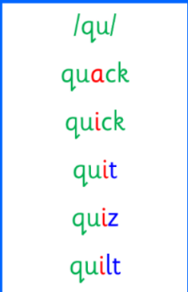 | Use any of the activities to develop your phonics skills. Can you check that you –  - can hear these sounds in words  - see these letters in words  - say these sounds in words  - sound out the words  write the words from your phoneme strips and common words.  Practise sounding out your cvc and spelling words.  Listen to your cvc and spelling words. Can you break them and then write them.  https://ictgames.com/mobilePage/writingRepeater/index.html
  Reading | Read your book to your adult.  Remember to tell them what your book is called. There are some words that we cannot sound out in our books yet as we have not learnt all of our spelling rules. Our adults at home can help with this. With all CVC words, however, we want to be using the letter sounds and blending those words to read. We are also focusing on the importance of using your finger to follow the words as you read.
  Writing | In writing lessons, we have been focusing on instructions and recipes.  Draw a set of instructions for how to look after a dog.  https://www.autodraw.com/
Numeracy | In class, we have been learning about height.  Go on a measurement scavenger hunt around your house.  Can you find tall and small, as well as long and short objects?
Other | Practice Verse 1 and the Chorus of “The Jeely Piece song” before our performance at the Scottish Assembly on Friday.  https://www.youtube.com/watch?v=ukTX0kKCSEY
Contact details | If you have any issues about homework please contact:  Miss Ronald eaaimee.ronald@glow.sch.uk  Miss Barrett at eajaye.barrett@glow.sch.uk

Common words list

a | at | it | in | an
am | did | and | can | ask
get | let | for | on | but
up | went | had | us | him

Tricky words list

the | I | is | are | of
be | me | we | he | have
you | was | to | do | so
no | go

