Homework 9th December
*Please bring your reading book and spelling words in your homework folder everyday as we will be using them in class.*
All Primary 1 children have Outdoor Learning on a Tuesday. Please bring or wear appropriate footwear and jackets.
Literacy
  Phonics – y and z  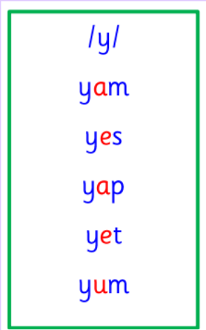  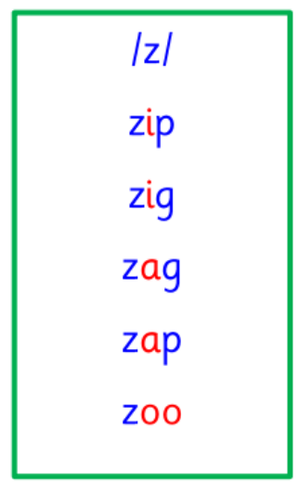  Tricky Words    Sometimes the lettes <o> + <u> can be code for the /oo/ sound. Sound the word out using this code for <o> + <u>.    Sometimes the letter <a> can be code for the /o/ sound. Sometimes the letter <s> can be code for the /z/ sound. Sound the word out using this code for <a> and <s>. | Use any of the activities to develop your phonics skills. Can you check that you –  - can hear these sounds in words  - see these letters in words  - say these sounds in words  - sound out the words  write the words from your phoneme strips and common words.  Practise sounding out your cvc and spelling words.  Listen to your cvc and spelling words. Can you break them and then write them.  https://ictgames.com/mobilePage/writingRepeater/index.html
  Reading  There are some words that we cannot sound out in our books yet as we havent learned all of our spelling rules, so our adults at home can help with this. With all CVC words, however, we want to be using the letter sounds and blending those words to read. | Read your book to your adult.  Remember to tell them what your book is called.  We are focusing in class the importance of using your finger to follow the words as you read.
  Personal writing | Personal Writing  Draw a picture of something you did today.  Tell your adult what it is. Try and write your sentence yourself.  Say your words nice and clearly then break them to help you spell. Remember finger spaces, full stops.  https://www.autodraw.com/
Numeracy | In class, we have been learning about symmetry.  Look for symmetry when you are out and about.  Can you see any symmetrical houses, streets, food?
Other | Practice your nativity part before our performance on Tuesday.  Please note that all children have been asked to wear a black t-shirt/long sleeve and black trousers/leggings for their performance. All other costumes are provided by the school.
Contact details | If you have any issues about homework please contact:  Miss Barrett at eajaye.barrett@glow.sch.uk  Miss Ronald eaaimee.ronald@glow.sch.uk

