Homework 25th November
Please note that learners will have outdoor learning on Tuesday this week. Please bring or wear appropriate footwear and jackets.
Please bring your reading book and spelling words in your homework folder every day as we will be using them in class.
Literacy
  Spelling  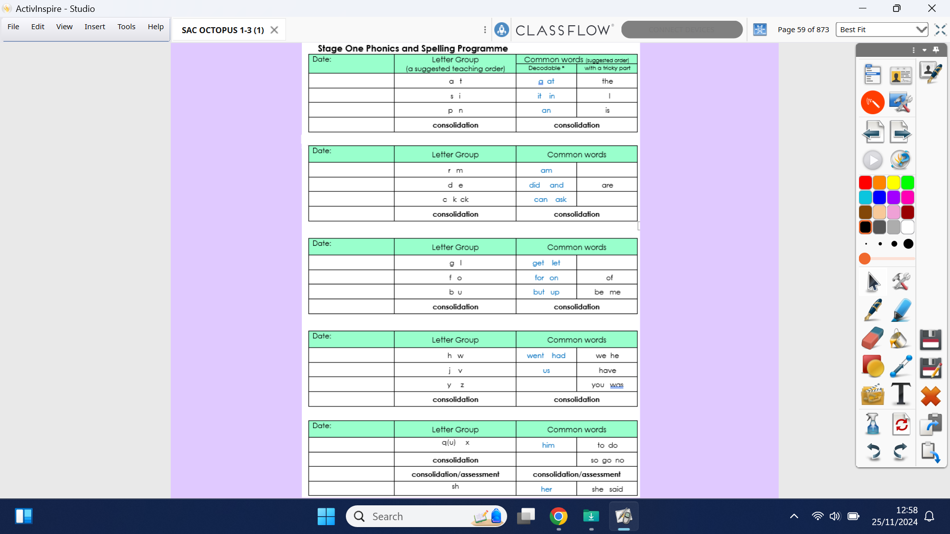  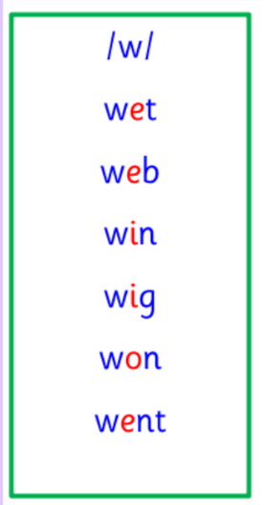  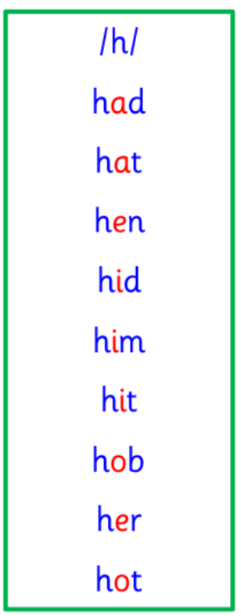 | Use any of the activities to develop your phonics skills. Can you check that you –  - can hear these sounds in words  - see these letters in words  - say these sounds in words  - sound out the words  - write the words from your phoneme strips and common words.
  Reading  Learners have received a new book today (Monday) into their homework folder. Please bring homework folders, with reading books, into class every day.  Please note that if books from the previous week have not been returned, then new books may not be issued due to numbers available. | Read your book to your adult. Focus firstly on key features of the text - the title, blurb, author and illustrator. Then you could:  - Retell the story, using your imagination.  - Make predictions.  - Go on a sound hunt in your book – can you find any of this week’s sounds?  - Talk about the characters and setting, and describe them.
  Writing  Personal writing | Draw a picture of something you did today. Tell your adult what it is. Try and write your sentence yourself. Say your words nice and clearly then break them to help you spell. Remember finger spaces, full stops and capital letters.  https://www.autodraw.com/
Numeracy | Practise saying your days of the week and months on the year in order. Talk about these with your adults, you could tell them: What month comes after November? What month comes before June? What day comes after Thursday? What day comes before Tuesday?  These songs will help you learn your days of the week and months of the year in order:  https://www.youtube.com/watch?v=mXMofxtDPUQ  https://www.youtube.com/watch?v=Fe9bnYRzFvk
Other | Speak to an adult about your trip to Stewarton library. What did you learn? What did you enjoy? Then, read some material from your new Book Bug bag.
If you have any issues about homework please contact:

Miss Ronald - eaaimee.ronald@glow.sch.uk
Miss Barrett - eajaye.barrett@glow.sch.uk

The QR code for the class blog is on the P1R class window and it has been updated, and any previous problems with access should now be sorted.
If you are struggling to access the QR code, then our school blog can also be found directly through the “Nether Robertland School” website. Thanks.

