Homework 18th November
Literacy
  Spelling  Consolidation week    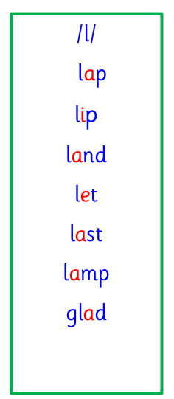  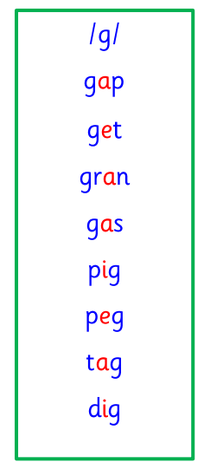  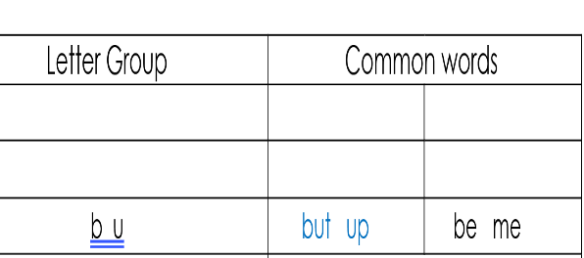  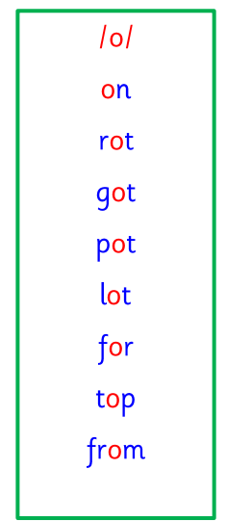  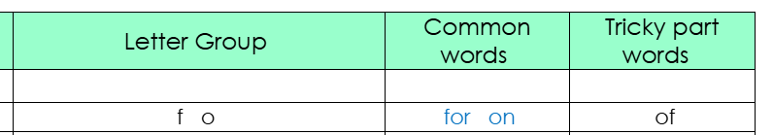  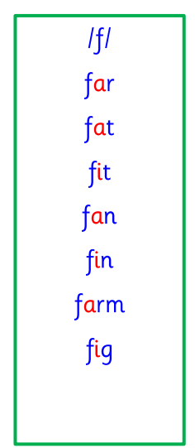  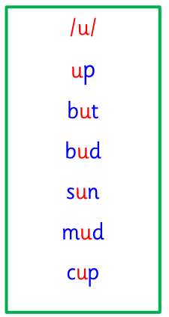  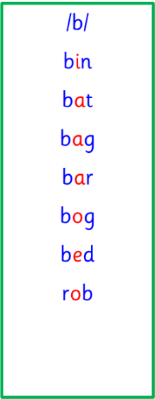 | This week is a consolidation week. We recap what we have learned before moving on to new learning.  G g, L l, get, let  F f, O o, for, on, of  Bb Uu, but, up, be, me  Use any of the activities to develop your phonics skills. Can you check that you –  - can hear these sounds in words  - see these letters in words  - say these sounds in words  - sound out the words  - write the words from your phoneme strips and common words.
  Reading  Learners have received a new book today (Monday) into their homework folder. Please bring homework folders, with reading books, into class every day. | Read your book to your adult. Focus firstly on key features of the text - the title, blurb, author and illustrator. Then you could:  - Retell the story, using your imagination.  - Make predictions.  - Go on a sound hunt in your book – can you find any of this week’s sounds?  - Talk about the characters and setting, and describe them.
  Writing  Letter formation and pencil control | We have been focusing on our letter formation and pencil control when writing our sounds in class; making sure that letters are the right size and facing the right way. We have also been focusing on writing our full names. Practice writing your name at home, and then practice writing your phonemes.  https://www.doorwayonline.org.uk/literacy/letter-and-number-formation/
Numeracy | We have been continuing to learn about time in class. This week, we were focusing on reading and understanding digital clocks.  Talk to your adults at home about digital clocks – what do they look like, how do we know it is o’clock, how do we know when it is AM or PM? Then, use the interactive digital clock on Top Marks to show these times: 2am, 11am, 4pm, 6pm, 10pm. Ask an adult to show you a time on the digital clock for you to read back to them. Then, you could go on a clock hunt around your house! How many clocks can you find?  https://www.topmarks.co.uk/time/teaching-clock  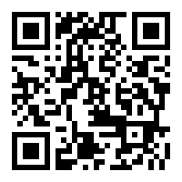
Other | On Tuesday, the JRSO team at NRPS are announcing a competition to design a Green Cross Code mascot. If you wish to enter, then you should design a new mascot for the Green Cross Code. This should be on A4 paper and you can use pencils and pens. Please write your name on it and submit any designs by Friday 22nd November to Miss Ronald.
If you have any issues about homework please contact:

Miss Ronald - eaaimee.ronald@glow.sch.uk
Miss Barrett - eajaye.barrett@glow.sch.uk

The QR code for the class blog is on the P1R class window and it has been updated, and any previous problems with access should now be sorted.
If you are struggling to access the QR code, then our school blog can also be found directly through the “Nether Robertland School” website. Thanks.

