Homework Monday ^{7th} October
*Please bring your reading book and spelling words in your homework folder everyday as we will be using them in class.*
All Primary 1 children have Outdoor Learning on a Tuesday. Please bring or wear appropriate footwear and jackets.
Literacy
  Phonics    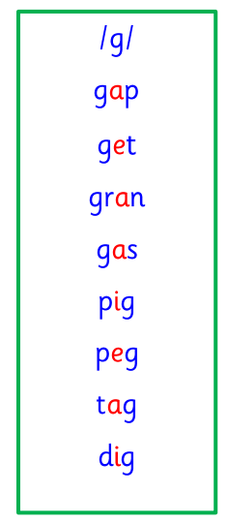  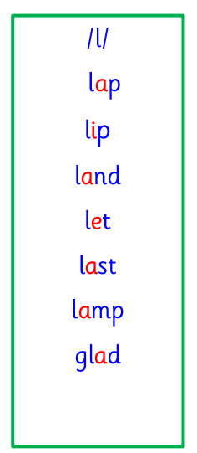 | This week is a consolidation week, where learning from the past few sessions is recapped before moving on to new learning.  Use any of the activities to develop your phonics skills  Remember to check-  - can hear these sounds in words  - see these letters in words  - say these sounds in words  - and write the words from your phoneme strips and common words
  Reading | Retell your book to an adult. Remember to tell them what your book is called.  Some things you could tell your adult is.  If:  your book title has any of your common words.  Who the characters in your book are.  How they are related.
  Writing | We have been practicing writing our first or first and second name.  You could try this at home using paint, pens or on an Ipad.  When we are confident writing our first and second name, we are focussing on the size and formation of our letters.
Numeracy | We have learned about 3D shapes.  Cube, cuboid, cone, sphere and cylinder.  Try to identify some of these shapes in real life with adults at home.
Other | It’s Halloween!  If you are going trick or treating and have a joke or song you’re going to perform.  Maybe you could practice before school on Thursday and we could hear it when you’re all dressed up!
If you have any issues about homework please contact
Miss Barrett at
eajaye.barrett@glow.sch.uk

