Homework Monday 22nd October
*Homework folders will stay in class this week*
All Primary 1 children have Outdoor Learning on a Tuesday. Please bring or wear appropriate footwear and jackets.
Literacy
  Phonics  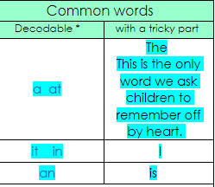  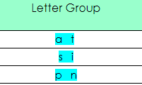  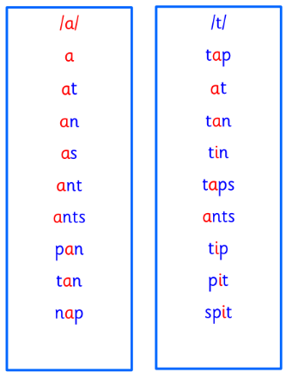  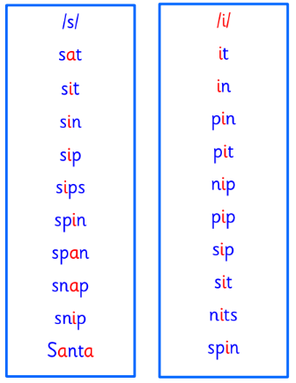  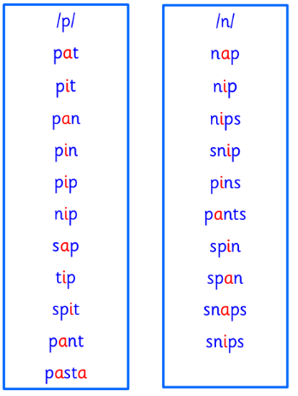 | This week is a consolidation week, where learning from the past few sessions is recapped before moving on to new learning.  Use any of the activities to develop your phonics skills  Remember to check-  - can hear these sounds in words  - see these letters in words  - say these sounds in words  - and write the words from your phoneme strips and common words
  Reading | Retell a book to an adult. Remember to tell them what your book is called.  Some things you could tell your adult is.  If:  your book title has any of your common words.  Who the characters in your book are.  How they are related.
  Writing | 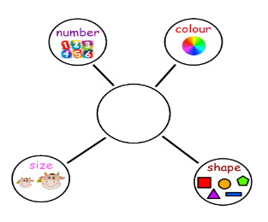  Here is the description bubble that we use in class to describe different characters. Choose a character from your favourite movie, book or tv show and give a verbal description to an adult at home.
Numeracy | Use the rekenrek we have used in class and show your adults how you use them.  Tell them how many red and white beads are on each row.  If you move all the red to the left how many red are still to the right?  https://mathsbot.com/manipulatives/rekenrek
Other | We have been learning about our similarities and differences and why they are so important.  Talk to an adult and see what is similar and different about you both?
If you have any issues about homework please contact Miss Barrett at
eajaye.barrett@glow.sch.uk

