Homework Monday ^{30th} September
*Please bring your reading book in your homework folder everyday as we will be using them in class.*
Following the Parent Information Evening, we had some questions regarding how to best support spelling at home. Here are some links to help with the pronunciation of sounds and blending. | https://www.youtube.com/watch?v=-Qpj1j488PM  https://www.youtube.com/watch?v=mjyk4ULW7lk  https://www.youtube.com/watch?v=VE9ZYKGFx68  The songs and Mr Thorne clips are available for all our sounds covered so far. You can look back on these to remind you of your previous learning.
In class we use the Hi- Five hand  Say the word cap  Break it c a p  Make it (we do this in class with magnetic letters)  Blend and read the word  Now write the word | 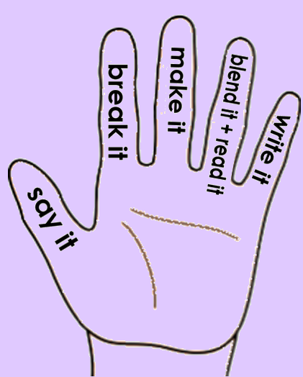
All Primary 1 children have Outdoor Learning on a Tuesday. Please bring or wear appropriate footwear and jackets.

Literacy
  Phonics  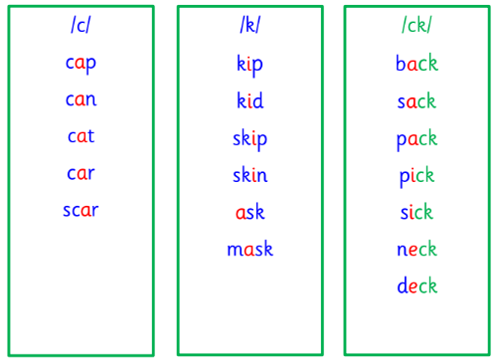 | Use any of the activities to develop your phonics skills  Remember to check-  - can hear these sounds in words  - see these letters in words  - say these sounds in words  - and write the words from your phoneme strips and common words
  Reading | Retell the story in your book using the picture clues to help you.  Here is a text that someone from your family could read to you. Listen carefully and then use what you have heard to answer the questions.  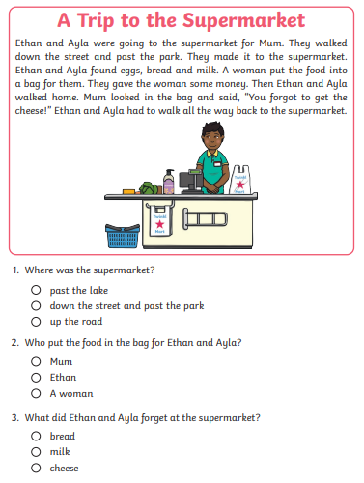
  Writing | Try using this handwriting tool to teach someone in your home how to form their letters. Choose from the letters that we have already covered (s, a, t, p, I, n, m, r, d and e).  https://ictgames.com/mobilePage/skyWriter/index.html
Numeracy | Can you use your knowledge of 2D and 3D shapes to identify these shapes?  https://www.topmarks.co.uk/shapes/2d-shape-reveal  (level one for the first link please)  https://ictgames.com/mobilePage/shiftingShapes/index.html  Can you go on a 2D and 3D shape hunt in your home or on a walk?  What are the shapes used for? Can you think of a reason why some of the shapes have been used for what they have been used for?
Other | Can you try an activity like skipping, dancing or tying your shoes? Try it a few times over the course of the week and see if you can become better, quicker or more independent at it.
If you have any issues about homework please contact Miss Whiteford on eavictoria.whiteford@glow.sch.uk
and Miss Barrett at
eajaye.barrett@glow.sch.uk

