Homework Tuesday ^{24th} September
*Please bring your reading book and spelling words in your homework folder everyday as we will be using them in class.*
All Primary 1 children have Outdoor Learning on a Tuesday. Please bring or wear appropriate footwear and jackets.
Literacy
  Phonics  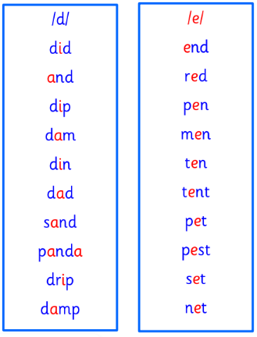 | Use any of the activities to develop your phonics skills  Remember to check-  - can hear these sounds in words  - see these letters in words  - say these sounds in words  - and write the words from your phoneme strips and common words
  Reading | Retell the story in your book using the picture clues to help you.  Remember to include who, what, where and when.
  Writing | Use the handwriting tool that we have used in class to work on letters that you find tricky or would like to make neater.  https://edu-tools.github.io/
Numeracy | Can you use this link to show your family your skills on a rekenrek?  You could ask them to count out a number on it and you could check it.  You could pick a number from 0-20 and show the different ways that you can make it on the rekenrek.  https://toytheater.com/rekenrek/
Other | Our McMillian Coffee Morning is on Friday, can you role play a cafe or coffee morning with your family? Think about what would be on the menu, how would you speak to your customers to make them feel welcome? What other duties apart from serving and taking orders would you need to do to keep your cafe or coffee morning going (washing dishes, taking payment/donations, setting up tables, cooking)?
If you have any issues about homework please contact Miss Whiteford on eavictoria.whiteford@glow.sch.uk
and Miss Barrett at
eajaye.barrett@glow.sch.uk

