Homework Tuesday ^{16th} September
*Please bring your reading book and spelling words in your homework folder everyday as we will be using them in class.*
All Primary 1 children have Outdoor Learning on a Tuesday. Please bring or wear appropriate footwear and jackets.
Literacy
  Phonics  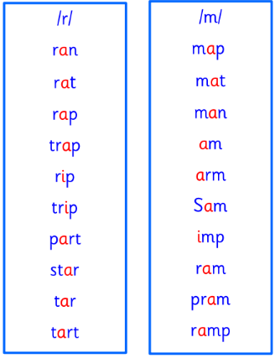 | Use any of the activities to develop your phonics skills  Remember to check-  - can hear these sounds in words  - see these letters in words  - say these sounds in words  - and write the words from your phoneme strips and common words
  Reading | Read a story with your family. Before turning each page can you predict (guess) what might happen?
  Writing | Can you write the capital and lower case letters for the sounds we have learned so far?  Aa Tt Ss Ii Pp Nn
Numeracy | Use the QR code or link to develop your numbers to 20 skills. You can play find the missing number or find the number 1 less/1 more.  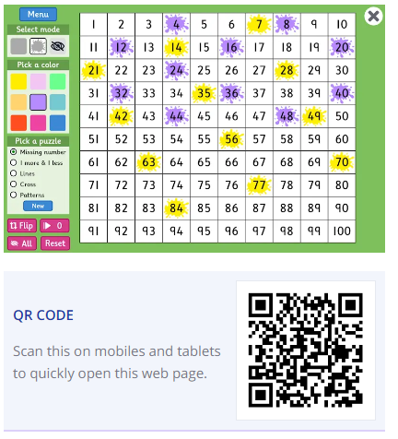  https://www.topmarks.co.uk/learning-to-count/paint-the-squares
Other | Can you give yourself a compliment? It could be about trying hard with something you find tricky, doing a task well or for being a good friend.
If you have any issues about homework please contact Miss Whiteford on eavictoria.whiteford@glow.sch.uk
and Miss Barrett at
eajaye.barrett@glow.sch.uk

