Homework Monday ^{9th} September
*Please bring your reading book in your homework folder everyday as we will be using them in class.*
All Primary 1 children have Outdoor Learning on a Tuesday. Please bring or wear appropriate footwear and jackets.
Literacy
  Phonics  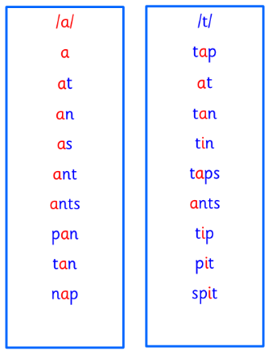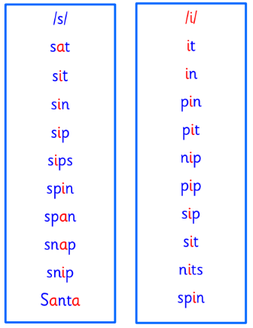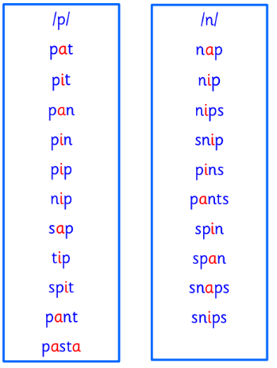 | This week is a consolidation week. We recap what we have learned before moving on to new learning.  Can you check that you  - can hear these sounds in words  - see these letters in words  - say these sounds in words  - and write the words from your phoneme strips and common words
  Reading | Retell the story in your book using the picture clues to help you.  Remember to include who, what, where and when.
  Writing | Can you write your name independently?  Can you write your first and second name?
Numeracy | 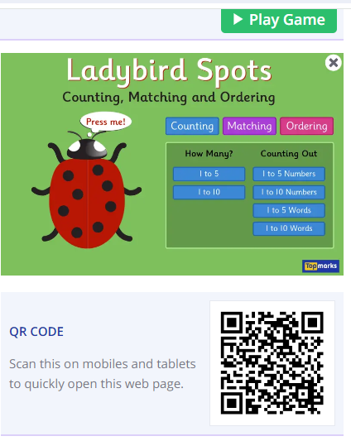  Scan this QR code or use this link to count, match and order numbers to 10.  https://www.topmarks.co.uk/learning-to-count/ladybird-spots
Other | Can you bring a small toy from home to talk to the class about on Friday?
If you have any issues about homework please contact Miss Whiteford on eavictoria.whiteford@glow.sch.uk
and Miss Barrett at
eajaye.barrett@glow.sch.uk

