Primary 1 Homework Monday 3rd June
Common Words | Please try to read and spell all common words daily.  got if came  The spelling activity grid in each homework folder will give you some ideas.
Phoneme Strips | Please try to read and spell all phoneme words. This week we will be consolidating “ck” sound. Please try to say the sound and spell out words with these sounds.  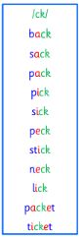
Reading Book(s) | Try to read your book daily.  Please use the Active Reading mat to ask your child questions about their reading book.
Numeracy | 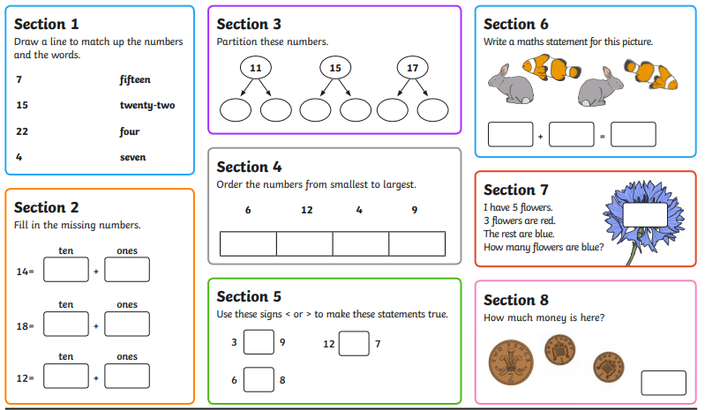
Wild Challenge | Can you use items from your paper and plastic recycling to create your very own minibeast?  This home learning activity will be open for two weeks so there is lots of time for you to collect and use items for recycling.  Bring your recycled materials minibeast in to show your peers on Monday 10th June.
If you have any issues about homework please contact Miss Whiteford on eavictoria.whiteford@glow.sch.uk
or Mrs Henderson on eacarol.henderson@glow.sch.uk
P1/2W have Outdoor Learning on Wednesday. Please ensure that your child has suitable outdoor clothes. Thank you.

