Primary 2 Jellyfish Homework Monday 28th May
P1/2 W will have Outdoor Learning on Wednesday
Common Words | Please try to read and spell the common words daily.  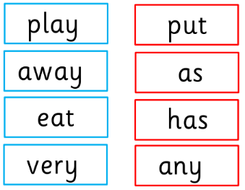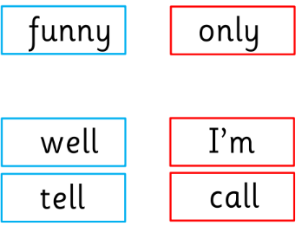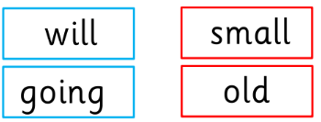  The spelling activity grid in each homework folder will give you some ideas.
Phoneme Strips | Please try to read and spell all phoneme words. This week we will be consolidating the sounds that we have covered in P2.  Here is a list of half of them.  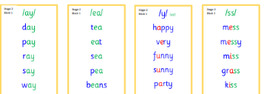  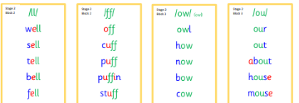  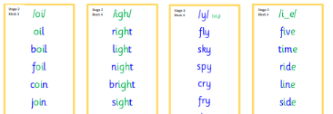  Please try to say the sound, blend and write them.
Reading Book(s) | Please read your reading book daily. Bring it to school every day so that you can use it during our literacy tasks.  Remember to ask questions and answer questions about your reading book. If you find it tricky to remember our reading questions use your reading mat.
Numeracy | 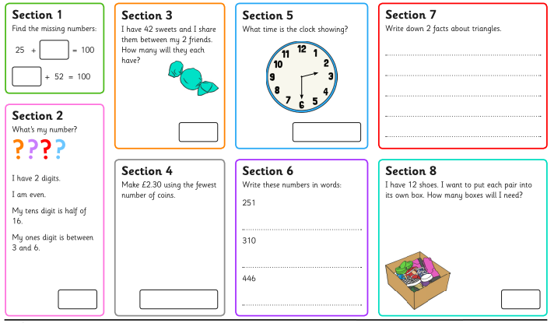
Challenge | Can you use items from your paper and plastic recycling to create your very own minibeast?  This home learning activity will be open for two weeks so there is lots of time for you to collect and use items for recycling.  Bring your recycled materials minibeast in to show your peers on Monday 10th June.
 | If you have any issues about homework please contact Miss Whiteford on eavictoria.whiteford@glow.sch.uk

We would very grateful if your child could bring their reading book and homework folder to school each day. Thank you.

