Primary 2 Lionfish Homework Monday 20th May
P1/2 W will have Outdoor Learning on Wednesday
Common Words | Please try to read and spell the common words daily.  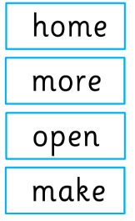  The spelling activity grid in each homework folder will give you some ideas.
Phoneme Strips | Please try to read and spell all phoneme words. This week we will be finding out about “o-e” sound.  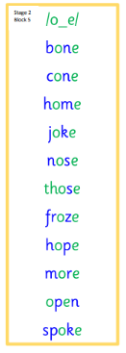  Please try to say the sound, blend and write them.
Reading Book(s) | Please read your reading book daily. Bring it to school every day so that you can use it during our literacy tasks.  Remember to ask questions and answer questions about your reading book. If you find it tricky to remember our reading questions use your reading mat.
Numeracy | We have been using non-standard measuring units to estimate then check our work to measure things around us. Can you show someone in your home your estimation and measuring skills using hands, feet, counters or pens?
Challenge | Can you share with someone from home what you have learned so far about our topic Mini Beasts?  You could verbally tell them, draw pictures and talk about them or make your own minibeast fact file.
 | If you have any issues about homework please contact Miss Whiteford on eavictoria.whiteford@glow.sch.uk

We would very grateful if your child could bring their reading book and homework folder to school each day. Thank you.

