Primary 2 Lionfish Homework Monday 22nd April
P1/2 W will have Outdoor Learning on Wednesday
Common Words | Please try to read and spell the common words daily. (walk, want, how, now, down, your, our, out and about)  The spelling activity grid in each homework folder will give you some ideas.
Phoneme Strips | Please try to read and spell all phoneme words. This week we will be finding out about “oi, ow, ou” sound.  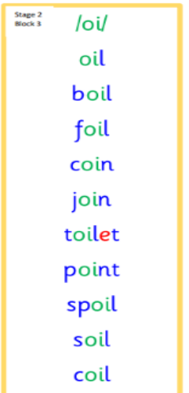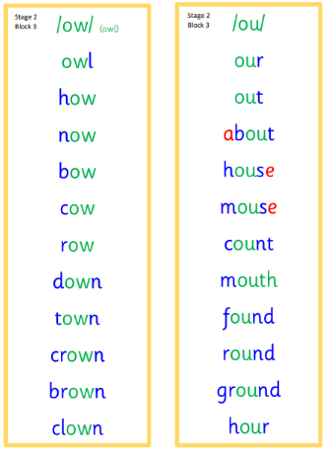  Please try to say the sound, blend and write them.
Reading Book(s) | Choose a book or text from home. Can you find oi ,ou or ow words in it? Can you identify some capitals, full stops and questions marks?
Numeracy | Use your developing mearure skills to complete these tasks.
Challenge | Think about your P2 journey so far, discuss with someone from home three things that you have learned and three things or areas that you would like learn or improve.
If you have any issues about homework please contact Miss Whiteford on eavictoria.whiteford@glow.sch.uk
or Mrs Henderson on eacarol.henderson@glow.sch.uk
or Miss Barrett on eajaye.barrett@glow.sch.uk

We would very grateful if your child could bring their reading book and homework folder to school each day. Thank you.

