Primary 2 Jellyfish Homework Monday 25th March
P1/2 W will have Outdoor Learning on Wednesday
Common Words | Please try to read and spell the common words daily. (knew, know)  The spelling activity grid in each homework folder will give you some ideas.
Phoneme Strips | Please try to read and spell all phoneme words. This week we will be finding out about “kn” sound.  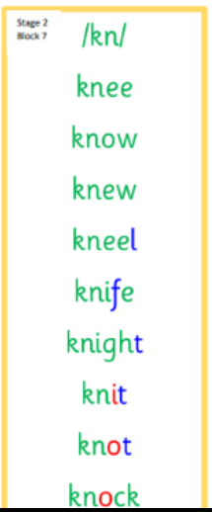  Please try to say the sound, blend and write them.
Reading Book(s) | Choose a book or text from home. Can you find kn words in it? Can you identify some capitals, full stops and questions marks?
Numeracy | 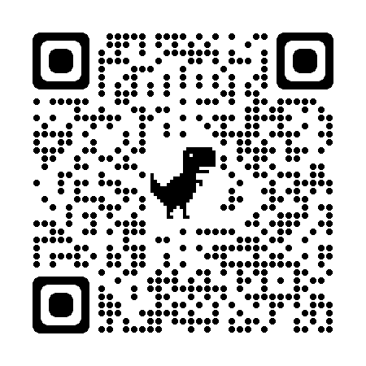 Use this QR code to consolidate your addition and subtraction skills.
Challenge | Go for a walk with your family or have a look when you are in a car or a bus. What signs of Spring can you see?
If you have any issues about homework please contact Miss Whiteford on eavictoria.whiteford@glow.sch.uk
or Mrs Henderson on eacarol.henderson@glow.sch.uk
or Miss Barrett on eajaye.barrett@glow.sch.uk

We would very grateful if your child could bring their reading book and homework folder to school each day. Thank you.

