Primary 1 Homework
Common Words | We are focusing on our common words  much, them  Please try to read and spell all common words daily.  The spelling activity grid in each homework folder will give you some ideas.
Phoneme Strips | We are focusing on the “ch” sound this week.  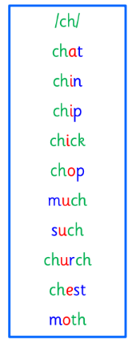
Reading Book(s) | Choose a book or text from home. Can you find ch words in it? Can you identify some capitals, full stops and questions marks?  Challenge- Can you answer our comprehension questions of who, what, where and when in your book?
Numeracy and Mathematics | 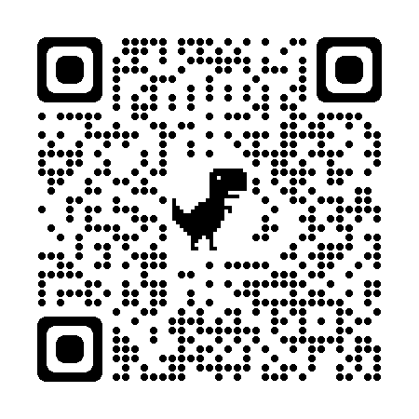 Use this QR code to consolidate your addition and subtraction skills.
Challenge | Go for a walk with your family or have a look when you are in a car or a bus. What signs of Spring can you see?
If you have any issues about homework please contact Miss Whiteford on eavictoria.whiteford@glow.sch.uk
or Mrs Henderson on eacarol.henderson@glow.sch.uk
or Miss Barrett
on eajaye.barrett @glow.sch.uk
P1H and P1B have Outdoor Learning on Monday and P1/2W on Wednesday. We would be grateful if your child could arrive with suitable outdoor clothes. Thank you.

We would very grateful if your child could bring their reading book and homework folder to school each day. Thank you.

