Primary 1 Homework
Common Words | We are focusing on our new common words this, that, them  Please try to read and spell all common words daily.  The spelling activity grid in each homework folder will give you some ideas.
Phoneme Strips | We are focusing on the “th” – the  sound this week. Please try to say the sound and show the action for each sound.
Reading Book(s) | Try to read your book daily.  Please use the Active Reading mat to ask your child questions about their reading book.  Challenge- Can you answer our comprehension questions of who, what, where and when in your book?
Numeracy and Mathematics | Can you put the days of the week in order?  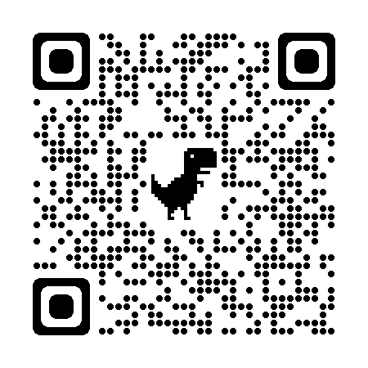  Challenge, can you add the missing letter to the days of the week?  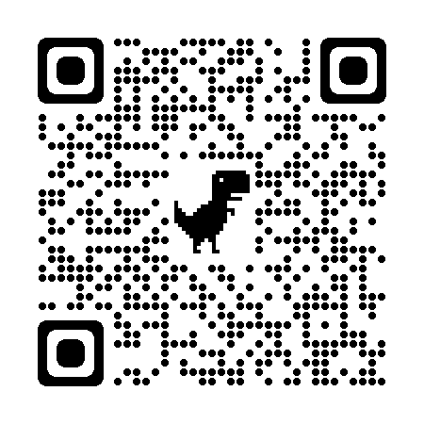
Challenge | 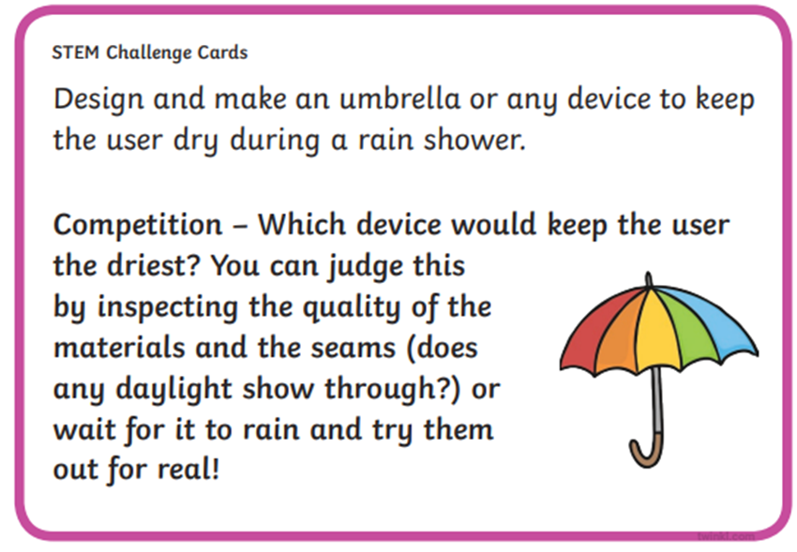
If you have any issues about homework please contact
Miss Barrett
on eajaye.barrett @glow.sch.uk
P1H and P1B have Outdoor Learning on Monday and P1/2W on Wednesday. We would be grateful if your child could arrive with suitable outdoor clothes. Thank you.

We would very grateful if your child could bring their reading book and homework folder to school each day. Thank you.

