Primary 2 Pufferfish Homework Monday 11th March
P1/2 W will have Outdoor Learning on Wednesday
Common Words | Please try to read and spell the common words daily. (much, them)  The spelling activity grid in each homework folder will give you some ideas.
Phoneme Strips | Please try to read and spell all phoneme words. This week we will be finding out about “ch” sound.  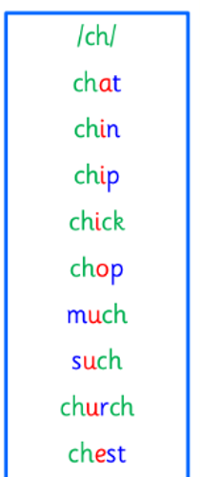  Please try to say the sound, blend and write them.
Reading Book(s) | Try to read your book daily.  Please use the Active Reading mat to ask your child questions about their reading book.
Numeracy |  Use this QR code to develop your time telling skills with o’clock and half past. You can also use clocks around your home to work on your time skills.
Challenge | Like last week, use a mirror and draw a self-portrait. Can you redraft and use your editing skills to improve your work?
If you have any issues about homework please contact Miss Whiteford on eavictoria.whiteford@glow.sch.uk
or Mrs Henderson on eacarol.henderson@glow.sch.uk
or Miss Barrett on eajaye.barrett@glow.sch.uk

We would very grateful if your child could bring their reading book and homework folder to school each day. Thank you.

