Primary 1 Homework Monday 11th March
Common Words | We are focusing on our new common words with, my, by.  Please try to read and spell all common words daily.  The spelling activity grid in each homework folder will give you some ideas.
Phoneme Strips | We are focusing on the “th” sound this week. Please try to say the sound and show the action for each sound.  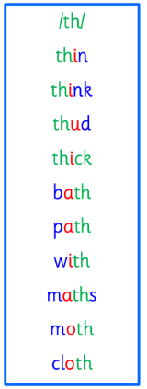
Reading Book(s) | Try to read your book daily.  Please use the Active Reading mat to ask your child questions about their reading book.  Challenge- Can you answer our comprehension questions of who, what, where and when in your book?
Numeracy and Mathematics | We are learning about time and how to describe different times such as yesterday, last week, tomorrow, before, after and days of the week.  Have discussion with you adult at home, can they ask you questions about your week using different time vocabulary?  Eg What did you do on Tuesday?  What did you do before you brushed your teeth?  When are you next going to beavers?  Challenge-Can you create a weekly timetable which shows what you did in the morning, what you did after and what you did at night?  You can bring this in and we will use it in class to help us with our learning.
Challenge | Go for a walk with your family or have a look when you are in a car or a bus. What signs of Spring can you see?
If you have any issues about homework please contact Miss Whiteford on eavictoria.whiteford@glow.sch.uk
or Mrs Henderson on eacarol.henderson@glow.sch.uk
or Miss Barrett
on eajaye.barrett @glow.sch.uk
P1H and P1B have Outdoor Learning on Monday and P1/2W on Wednesday. We would be grateful if your child could arrive with suitable outdoor clothes. Thank you.

We would very grateful if your child could bring their reading book and homework folder to school each day. Thank you.

