Primary 1 Homework
Common Words | We are focusing on our common words  she said her  Please try to read and spell all common words daily.  The spelling activity grid in each homework folder will give you some ideas.
Phoneme Strips | We are focusing on the “sh” sound this week. Please try to say the sound, read your ‘sh’ words  Challenge- Adults at home ask your Primary 1 to write one of their ‘sh’ words independently. Can they break the words into their sounds  E.g. SH A R K
Reading Book(s) | Try to read your book daily.  Please use the Active Reading mat to ask your child questions about their reading book.  Challenge- Can you answer our comprehension questions of who, what, where and when in your book?
Numeracy and Mathematics | Can you use this QR code to show someone in your home your money skills? You could identify different coins and notes individually, add amounts of money together or make the same amount of money using different coin combinations.  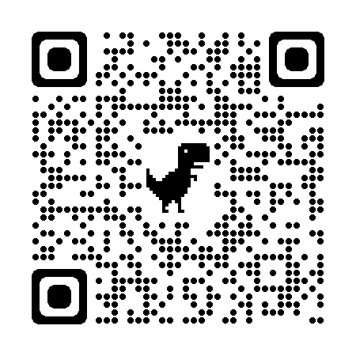  Challenge: choose counting coins: 1p to 10p to add amounts together
Challenge | Go for a walk with your family or have a look when you are in a car or a bus. What signs of Spring can you see?
If you have any issues about homework please contact Miss Whiteford on eavictoria.whiteford@glow.sch.uk
or Mrs Henderson on eacarol.henderson@glow.sch.uk
or Miss Barrett
on eajaye.barrett @glow.sch.uk
P1H and P1B have Outdoor Learning on Monday and P1/2W on Wednesday. We would be grateful if your child could arrive with suitable outdoor clothes. Thank you.

We would very grateful if your child could bring their reading book and homework folder to school each day. Thank you.

