Primary 2 Jellyfish Homework Monday 26th February
P1/2 W will have Outdoor Learning on Wednesday
Common Words | Please try to read and spell the common words daily. (new, who, friend)  The spelling activity grid in each homework folder will give you some ideas.
Phoneme Strips | Please try to read and spell all phoneme words. This week we will be finding out about “ew” sound.  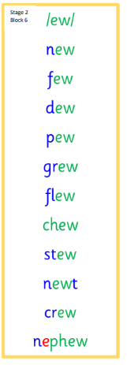  Please try to say the sound, blend and write them.
Reading Book(s) | Try to read your book daily.  Please use the Active Reading mat to ask your child questions about their reading book.
Numeracy | Can you help someone in your home find the total of some items by adding up their amounts? Can you give change from 20p and £1 (simple amounts from £1 for example 20p, 30p and 50p using your number bonds to 10 skills). You could also set up a pretend shop at home and showcase your money skills with someone at home.
Challenge | Can you find a task at home that you could learn to do independently? I could be sweeping up, sorting paper and plastic recycling or tying your shoes. Set yourself a challenge to become independent in it.
If you have any issues about homework please contact Miss Whiteford on eavictoria.whiteford@glow.sch.uk
or Mrs Henderson on eacarol.henderson@glow.sch.uk
or Miss Barrett on eajaye.barrett@glow.sch.uk

We would very grateful if your child could bring their reading book and homework folder to school each day. Thank you.

