Primary 2 Jellyfish Homework Monday 19th February
P1/2 W will have Outdoor Learning on Wednesday
Common Words | Please try to read and spell the common words daily. (use, could, would)  The spelling activity grid in each homework folder will give you some ideas.
Phoneme Strips | Please try to read and spell all phoneme words. This week we will be finding out about “u-e” sound.  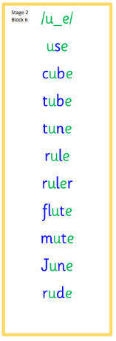  Please try to say the sound, blend and write them.
Reading Book(s) | Try to read your book daily.  Please use the Active Reading mat to ask your child questions about their reading book.
Numeracy | Can you identify coins and notes used to pay for things? Can you help someone in your home pay for something? Can you give change from 10p and 20p (use you subtraction skills). You could also set up a pretend shop at home and showcase your money skills with someone at home.
Challenge | Please speak with your family about the curricular areas in school that you enjoy, discuss the things that you are confident in doing (for example reading your common words or subtraction within 10). Then discuss are area that you are not as confident in, can you come up with some ideas for you next steps in your learning journey?
If you have any issues about homework please contact Miss Whiteford on eavictoria.whiteford@glow.sch.uk
or Mrs Henderson on eacarol.henderson@glow.sch.uk
or Miss Barrett on eajaye.barrett@glow.sch.uk

We would very grateful if your child could bring their reading book and homework folder to school each day. Thank you.

