Primary 2 Jellyfish Homework Monday 5th February
P1/2 W will have Outdoor Learning on Wednesday
Common Words | Please try to read and spell the common words daily. (much, these)  The spelling activity grid in each homework folder will give you some ideas.
Phoneme Strips | Please try to read and spell all phoneme words. This week we will be finding out about “e-e” sound.  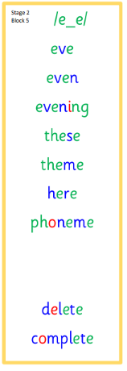  Please try to say the sound, blend and write them.
Reading Book(s) | Try to read your book daily.  Please use the Active Reading mat to ask your child questions about their reading book.
Numeracy | Can you use this QR code to consolidate you addition and subtraction knowledge. Click the addition or subtraction option on the page then choose 1-9, 1-19 or 1-29.  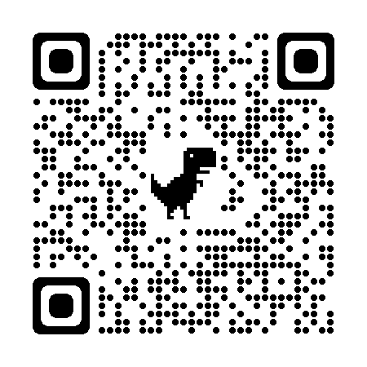
Challenge | Can you discuss your day at school? What did you do? Who did you play with? What did you enjoy? What did you find tricky?
If you have any issues about homework please contact Miss Whiteford on eavictoria.whiteford@glow.sch.uk
or Mrs Henderson on eacarol.henderson@glow.sch.uk
or Miss Barrett on eajaye.barrett@glow.sch.uk

We would very grateful if your child could bring their reading book and homework folder to school each day. Thank you.

