Primary 1 Homework Monday 22nd January
P1/2W will have Outdoor Learning on Wednesday. P1B and P1H will have Outdoor Learning on Monday. Please ensure your child brings suitable outdoor clothes. Thank you.
Common Words | Please try to read and spell all common words daily. (you, was)  The spelling activity grid in each homework folder will give you some ideas.
Phoneme Strips | This week is a consolidation week where we go over learning from the previous few weeks. Please try to read and spell all phoneme words. This week we will be recapping h, w, j, v, y and z. Please try to say the sound and show the action for each sound.  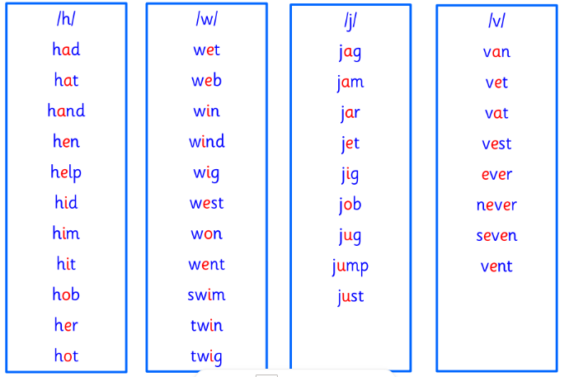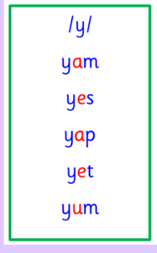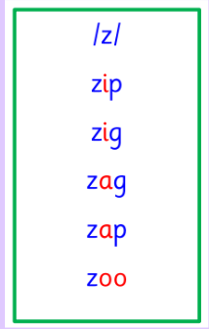
Reading Book(s) | Try to read your book daily.  Please use the Active Reading mat to ask your child questions about their reading book.
Numeracy | Following our pattern work last week, can you create your own patterns using this games?  https://www.coolmath4kids.com/manipulatives/pattern-blocks
Scots Poem  (please see homework folder) | Primary 1 will be learning “Mince and Tatties” for our Celebration of Scots Language. We would be grateful if you could help your child learn the words at home. Thank you.
If you have any issues about homework please contact Miss Whiteford on eavictoria.whiteford@glow.sch.uk
or Mrs Henderson on eacarol.henderson@glow.sch.uk
or Miss Barrett
on eajaye.barrett@glow.sch.uk

We would very grateful if your child could bring their reading book and homework folder to school each day. Thank you.

Going to add this to my home page
This term we will be having a “Celebration of Scots Language” (February) and Primary 1 will be learning the poem “Mince and Tatties”. We would be very grateful if you could help your child to recite the poem at home. You could talk about the Scots words and see if you know what the poem is about. Once you feel confident that you have learnt your poem why not have a go at getting someone at home to film or record you or you could recite your poem to you class.
Have fun Primary 1!
Mince and Tatties by J.K. Annand
I dinna like hail tatties
Pit on my plate o mince
For when I tak my denner
I eat them baith at yince.
Sae mash and mix the tatties
Wi mince into the mashin,
And sic a tasty denner
Will aye be voted ‘Smashin!’

