Primary 2 Jellyfish Homework Monday 15th January
P1/2 W will have Outdoor Learning on Wednesday
Common Words | Please try to read and spell the common word daily. (time)  The spelling activity grid in each homework folder will give you some ideas.
Phoneme Strips | Please try to read and spell all phoneme words. This week we will be finding out about “i-e” sound.  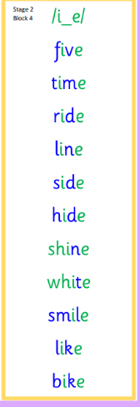  Please try to say the sound, blend and write them.
Reading Book(s) | Try to read your book daily.  Please use the Active Reading mat to ask your child questions about their reading book.
Numeracy | Can you play the number game on Toy Theatre?  https://toytheater.com/math-flash-cards/  Or make your own addition and subtraction flashcards like these and play a family member to find out who can find the answers quickest.  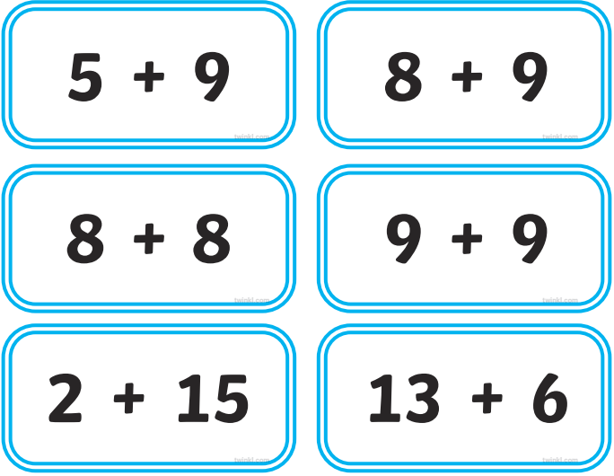
Challenge | Can you write a few sentences about your news? Remember to include who, what, where and when.
If you have any issues about homework please contact Miss Whiteford on eavictoria.whiteford@glow.sch.uk
or Mrs Henderson on eacarol.henderson@glow.sch.uk
or Miss Barrett on eajaye.barrett@glow.sch.uk

We would very grateful if your child could bring their reading book and homework folder to school each day. Thank you.

