Primary 2 Pufferfish Homework Monday 15th January
P1/2 W will have Outdoor Learning on Wednesday
Common Words | Please try to read and spell the common word daily. (will)  The spelling activity grid in each homework folder will give you some ideas.
Phoneme Strips | Please try to read and spell all phoneme words. This week we will be finding out about “oy” sound.  Please try to say the sound, blend and write them.
Reading Book(s) | Try to read your book daily.  Please use the Active Reading mat to ask your child questions about their reading book.
Numeracy | Can you play the number game on Toy Theatre?  https://toytheater.com/math-flash-cards/  Or make your own addition and subtraction flashcards like these and play a family member to find out who can find the answers quickest.  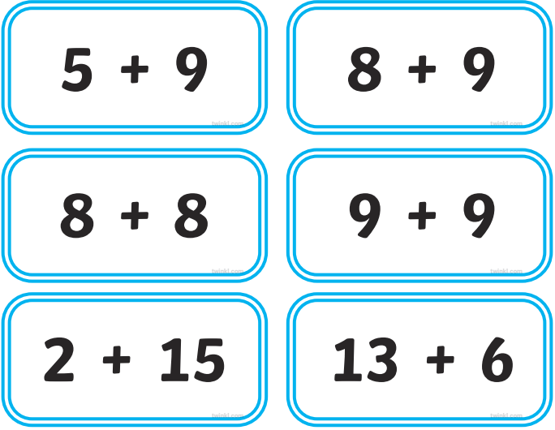
Challenge | Can you write a few sentences about your news? Remember to include who, what, where and when.
If you have any issues about homework please contact Miss Whiteford on eavictoria.whiteford@glow.sch.uk
or Mrs Henderson on eacarol.henderson@glow.sch.uk
or Miss Barrett on eajaye.barrett@glow.sch.uk

We would very grateful if your child could bring their reading book and homework folder to school each day. Thank you.

