Primary 2 Jellyfish Homework Monday 20th November
P1/2 W will have Outdoor Learning on Wednesday
Common Words | Please try to read and spell all common words daily. (how, now, down, your)  The spelling activity grid in each homework folder will give you some ideas.
Phoneme Strips | Please try to read and spell all phoneme words. This week we will be consolidating the “ow” as in owl sound.  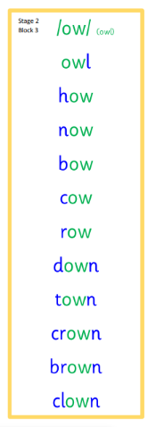  Please try to say the sound, blend and write them.
Reading Book(s) | Try to read your book daily.  Please use the Active Reading mat to ask your child questions about their reading book.
Numeracy | Can you play the number name game on Topmarks?  https://www.sheppardsoftware.com/math/early-math/number-words-fruit-splat-game/
Challenge | Can you write a few sentences about your news? Remember to include who, what, where and when.
 | If you have any issues about homework please contact Miss Whiteford on eavictoria.whiteford@glow.sch.uk

We would very grateful if your child could bring their reading book and homework folder to school each day. Thank you.

