Primary 1 Homework Monday 20th November
Common Words | Please try to read and spell all common words daily. (for, on, of)  The spelling activity grid in each homework folder will give you some ideas.
Phoneme Strips | Please try to read and spell all phoneme words. This week we will be finding out about “f and o”.  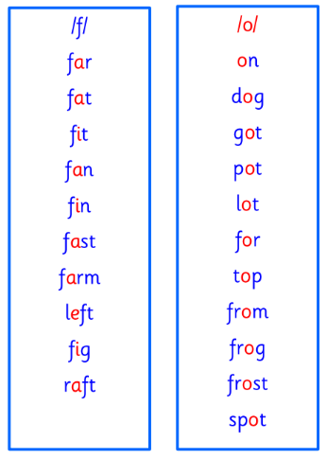  You may add each new phoneme strip to the key ring in the homework folder
Outdoor Learning | P1/2W will have Outdoor Learning on Wednesday. P1B and P1H will have Outdoor Learning on Monday. Please ensure your child brings suitable outdoor clothes. Thank you.
Numeracy | Can you play the number name game on Topmarks?  https://www.sheppardsoftware.com/math/early-math/number-words-fruit-splat-game/
Challenge | Can you write the number names and numerals and play a matching game with someone at home?
If you have any issues about homework please contact Miss Whiteford on eavictoria.whiteford@glow.sch.uk
or Mrs Henderson on eacarol.henderson@glow.sch.uk
or Miss Barrett
on eajaye.barrett@glow.sch.uk

We would very grateful if your child could bring their homework folder to school each day. Thank you.

