Primary 1 Homework Monday 13th November
Common Words | Please try to read and spell all common words daily. (get, let)  The spelling activity grid in each homework folder will give you some ideas.
Phoneme Strips | Please try to read and spell all phoneme words. This week we will be finding out about “g and l”.  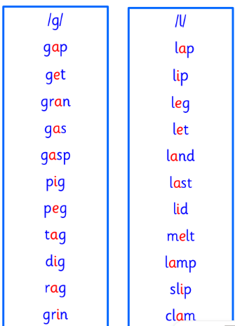  You may add each new phoneme strip to the key ring in the homework folder
Outdoor Learning | P1/2W will have Outdoor Learning on Wednesday. P1B and P1H will have Outdoor Learning on Monday. Please ensure your child brings suitable outdoor clothes. Thank you.
Numeracy | Can you use playdough or food like sandwiches to cut into different shapes and then split them into halves?  You can also use these activities to show your ability to identify halves.  https://wordwall.net/resource/16917500/half-not-half  https://wordwall.net/resource/55366545/math/half-or-2-equal-shares
Challenge | Can find a piece of clothing that you find tricky to put on and take off like a jacket with a zip or tying shoelaces? Try practising the skill for the item and challenge yourself to being independent at it by the end of the week.
If you have any issues about homework please contact Miss Whiteford on eavictoria.whiteford@glow.sch.uk
or Mrs Henderson on eacarol.henderson@glow.sch.uk
or Miss Barrett
on eajaye.barrett@glow.sch.uk

We would very grateful if your child could bring their homework folder to school each day. Thank you.

