Primary 2 Jellyfish Homework Monday 6th November
P1/2 W will have Outdoor Learning on Wednesday
Common Words | Please try to read and spell all common words daily. (going, old)  The spelling activity grid in each homework folder will give you some ideas.
Phoneme Strips | Please try to read and spell all phoneme words. This week we will be finding out about “ff” sound.  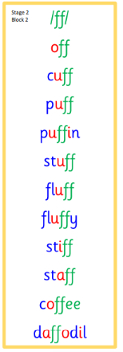  Please try to say the sound, blend and write them.
Reading Book(s) | Try to read your book daily.  Please use the Active Reading mat to ask your child questions about their reading book.
Numeracy | Can you find shapes or items in your home and half them? Can you count out items of different numbers up to 20 and find half of that quantity by sharing between you and a family member?  You could draw a pictorial image of your findings.  Use this link to find and recognise half of shapes and quantities.  https://kids.classroomsecrets.co.uk/resource/year-2-recognise-a-half-game/
Challenge | Can you bring in a favourite book or story to share with the class?
If you have any issues about homework please contact Miss Whiteford on eavictoria.whiteford@glow.sch.uk
or Mrs Henderson on eacarol.henderson@glow.sch.uk
or Miss Barrett on eajaye.barrett@glow.sch.uk

We would very grateful if your child could bring their reading book and homework folder to school each day. Thank you.

